
Erroneous Switch Guidance Document
Version 0.5
12 February 2026



Change History

Version Number | Date Published | Reason for Change / Updates Made
V0.1 | 30 October 2025 | Initial Draft to be shared with I0237 Working Group.
V0.2 | 03 December 2025 | Updated and published following feedback at the I0237 Working Group on 06/11/2025
V0.3 | 14 January 2026 | Updated to include domestic rejection scenarios
V0.4 | 19 January 2026 | Updated to include the use of “Technical” ES reason
V0.5 | 12 February 2026 | Updated to include summary of escalations process and peer review

Introduction
This document has been drawn up following discussion and agreement at the I0237 Working Group. It is intended to support the Erroneous Switch (ES) process as set out in Schedule 30 – Resolution of Consumer Facing Switching and Billing Issues, providing examples or additional detail that is not appropriate for the REC Main Body and its Schedules. Each piece of guidance is also published as an individual Wiki article on the REC Portal.

Use of Erroneous Switch Flag
The Erroneous Switch flag indicator is a mandatory Data Item within the Switch Request. The Data Item is set out as the DI90017 – erroneousSwitchResolutionInd.

Schedule 30 states the following:

6.9.3 | Following 6.9.2 and within 2 WDs, where the Initial Request is accepted by the Initiating Supplier and Associated Supplier. | Send a Valid Switch Request to re-register the erroneously switched RMP(s) on the CSS with the Erroneous Switch Flag indicator set to true. | Losing Supplier | CSS Provider | As set out in the Registration Services Schedule | CSS API

This means that the ES flag indicator should only be set to T once the ES has been agreed via the D0301 or RET process as set out in Schedule 30. It should not be used for any other reason, including ES prevention or flagging a potential ES.

All other Switch Requests should have the ES flag indicator set to F as they do not relate to an ES.

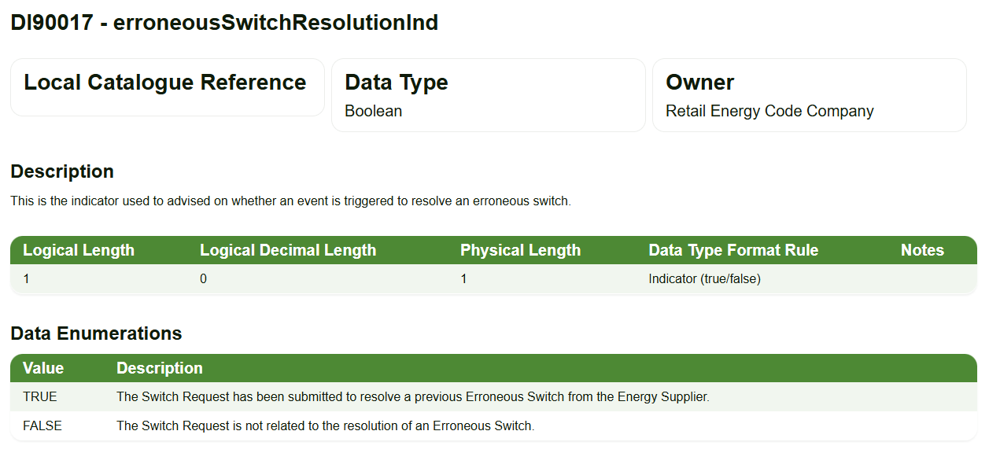

If a Losing Supplier wishes the Gaining Supplier to investigate a potential ES, they should follow the process as set out in Schedule 30, Section B.

Domestic rejection reasons
Any Associated Supplier receiving a D0301 or RET flow has the right to validate and reject the flow.

Domestic MPXNs (as determined by the Domestic Premise Indicator) have limited reasons for rejection. The table below provides valid and invalid scenarios.

Associated Supplier | Scenario | Valid Rejection? | Suggested Additional Comments
Gaining Supplier | Disagrees with the ES reason but agrees an ES has occurred | N – as the Gaining Supplier can respond with an updated ES Reason for Return. | N/A
Gaining Supplier | Disagrees with the ES reason and does not agree an ES has occurred | Y – only the Gaining Supplier can determine if an ES has occurred. | Need to be Consumer specific.  Examples of a comment could be – Not an ES – consumer confirmed Switch is valid.  Not an ES – cooling off period expired before Switch completed - no cancellation received.
Gaining or Losing Supplier | Disagrees with the Date of Transfer / Effective from Settlement Date (REGI) for New Supplier | Y - as reporting is based on the date. If Associated Supplier agrees and ES has happened, they should reject the ES and initiate a new one to limit the Consumer detriment. | Invalid date – should be dd/mm/yyyy
Gaining or Losing Supplier | Invalid Supplier MPID – ES flow has been sent to an incorrect Energy Supplier | Y – as the Energy Supplier has no relationship with the MPXN as part of the ES. This can include MPIDs in a company group as ES should be raised to the MPID at the time of the ES. | Incorrect MPID
Gaining or Losing Supplier | 2 years + since the date of the ES | Y – if this is the first initiation – it should be agreed bilaterally that both the Energy Suppliers will investigate an ES that is older than 24 months since the Erroneous Switch.  N – if it is not the first initiation – this means if an ES has been raised and rejected or not responded to within the 24 months since the Erroneous Switch. Normal validation rules should apply. | Over 24 Months– contact us via SDEP to discuss options.  N/A
Gaining or Losing Supplier | Address is not an exact match for the MPL on EES or GES | Y - The MPL should be used to populate the RET / D0301 (not the Consumer’s billing address) so if the address does not exactly match it suggests the ES has been raised on the incorrect MPXN. However, spelling mistakes can happen | Address does not match MPXN address on EES / GES
Gaining or Losing Supplier | No Consumer contact / If Consumer wants to come back; they need to contact us. | N – the ES process is built on Consumer only having to contact one Energy Supplier. This can include requesting no contact as part of the RET / D0301 flow. | N/A
Gaining Supplier | The account is in an occupier name / name on the RET / D0301 does not match our records | Depends on ES reason.  N – if flagged as “Incorrect MPXN” as these will be different details.  All other ES reasons could potentially be a valid rejection but need to consider if a Change of Occupier (CoO) has occurred.  CoO / CoS may also include a change of contract type from Domestic to Non-Domestic or vice versa so it may be valid that the names do not match | Need to be Consumer specific.
Losing Supplier | The name on the RET / D0301 does not match our records | Depends on ES reason.  N – if flagged as “Incorrect MPXN” as these will be different details.  All other ES reasons could potentially be a valid rejection but need to consider if a CoO has occurred. | Need to be Consumer specific.
Gaining or Losing Supplier | MSN does not match our records | N - Meter Serial Number is not used as a validation point. | N/A
Gaining or Losing Supplier | MPAN shows as de-energised in EES | N - Energisation status does not prevent a Switch. | N/A
Losing Supplier | Consumer was on the Price Cap (i.e. deemed terms) at the time of the Switch  / account is flagged as vacant or owner / occupier | N – no valid contract is not a valid rejection reason. A Consumer on the Price Cap should still be returned to the Losing Supplier | N/A

On a rejection the Associated Supplier (i.e. the Supplier receiving the RET /D0301) must complete the RET / D0301 response with the following:
- Use the appropriate ES status
  - Gas DI40213 - Status Response RET (B0030)
    - If rejected by the Losing Supplier use code N
    - If rejected by the Gaining Supplier (i.e. the supplier who gained in error) use code R.
  - Electricity DI50998 - Status of Erroneous Transfer (J1672)
    - If rejected by the Gaining Supplier use code C
    - If rejected by the Losing Supplier use code F
- Provide all reasons in additional information / comments field
  - If there is more than one reason populate as much information as possible (noting gas field is limited to 120 characters and electricity to 200 characters).
  - If needed use SDEP ES General Enquiries (PT0047 & PT0048) screens to provide more information.
    - Further details on how to use SDEP can be found in the SDEP User Guide.

“technical issues” Erroneous switch reason
The Technical Issues ES Reason for Return (J1671 / DI50997) value F is only available for electricity MPANs. Currently there is no definition of a “Technical Issues” ES reason code. However, it was previously defined before REC V3.0.

The I0237 Working Group has yet to determine if this ES Reason for Return is needed in the future. If the recommendation is that it remains the Working Group will provide a recommendation on how Schedule 30 or the Data Item will be clarified to set out the correct definition and check the assurance reporting is up to date. In the meantime, this guidance document can be used to provide clarification on when the Technical ES reason should be used.

The definition is:
Recorded Reason for ES | Definition | Typical Business Scenario
Technical Issue | Where the ES process is used by Electricity Suppliers to correct a technical problem whilst at the same time enhancing customer service. | Related MPAN (i.e. MPANs should be related but are not and have been split by a Switch).

This was traditionally an issue for Related MPANs prior to the introduction of the CSS, where separate Switch Requests had to be sent for each Related MPANs and accurate billing was dependent on all MPANs Switching to/from the same Supplier on the same date. It is expected that this issue should be significantly minimalised since the introduction of the CSS, as Related MPANs that are correctly grouped together will now Switch as a group.

It is possible that where Related MPANs have not been grouped together, or have been grouped incorrectly, this could still create an Erroneous Switch. This could either be because Related MPANs required to fulfil the contract with the Consumer were not included in the Switch (due to not being correctly related in SMRS) or MPANs that should not have been grouped as related were included in the Switch. In these scenarios, the Supplier may need to correct the Related MPAN grouping prior to initiating an ES (e.g. if only one MPAN in a group needs to be returned and a valid contract exists for all other MPANs).

Erroneous Switch Escalation Structure

Schedule 30 sets out the escalation stages for all processes, not just ES, in section 3.

Escalation Route | Pre-Conditions
Operational Contact | Response not received, or other required step not taken, within the timescales provided for in this REC Schedule, or such response or step is not satisfactory.
Contract Manager | After five Working Days of escalating the issue to the Operational Contact.
Code Manager | The Party may notify the Code Manager after five Working Days of escalating the issue to the Contract Manager.
REC Performance Assurance Board | As agreed between the Code Manager and the REC PAB.

Additionally there is REC user guide for the use of SDEP and a clarification guideline for SDEP escalations.

For an ES this specially means the following:

Escalation Route | When | Mechanism | What does this mean?
Operational Contact | New supplier response – 8WD  Old supplier response – 2WD  Old supplier re-registration – 2WD | PT0013 – electricity  PT0034 - gas | All information sent / responded to via SDEP. Only escalate once the SLA has passed
Contract Manager | 5WD after operational contact | PT0031 – electricity  PT0043 – gas | All information sent / responded to via SDEP
Code Manager | At least 5WD after Contract Manager | Complete template and submit to SDEPescalations@recmanager.co.uk | Code Manager will review and support through the appropriate channel
REC Performance Assurance Board | As required | Contract Manager presents to REC PAB | If the levels of detriment require this, it will be taken to REC PAB for review

If you require support at any stage, please contact the REC Service Desk.

Appendix 1 – Useful Terms
Populated using the definitions as set out in the REC Schedule 1 or the Supply Standard Licence Conditions. Where this has not been possible, this has been flagged.

Term | Acronym | What does it mean?
Associated Supplier |  | means, in respect of a problem under the Resolution of Consumer-Facing Switching and Billing Issues Schedule, each of the Energy Suppliers to which the Initiating Supplier sent an Initial Request.
Change of Occupier | CoO | means that the Consumer at a Premises has changed (or is due to change).
Data Item |  | means the most granular level of data defining a specific attribute in respect of a data type, the permissible values for which are defined and controlled in the Data Item Catalogue.
Domestic Premise Indicator | DPI | means the indicator used to identify a Domestic Premises.
Domestic Premises |  | has the meaning given in and is to be interpreted in accordance with standard condition 6 (Classification of premises)
Electricity Enquiry Service | EES | means the service described as such in the EES Service Definition.  Provided via https://www.ecoes.co.uk/
Erroneous Switch | ES | means where a Consumer has been switched to an Energy Supplier which does not have an Energy Contract in place, as further described in the Resolution of Consumer-Facing Switching and Billing Problems Schedule.
Gaining Supplier |  | means, in relation to a proposed Switch (or Switch), the Energy Supplier which is proposing to become the Registered Supplier at an RMP as a result of that proposed Switch (or which has become the Registered Supplier as a result of that Switch).
Gas Enquiry Service | GES | means: (a) until CSS Go-Live Date, the enquiry service provided pursuant to the UNC which allows authorised users to access Gas Retail Data; and (b) from CSS Go-Live Date, the service of that name procured by RECCo pursuant to the Data Access Schedule.  Provided via https://www.xoserve.com/products-services/data-products/gas-enquiry-service-ges/
Initial Request |  | means a notification from an Energy Supplier to another Energy Supplier to raise an issue which needs to be resolved in respect of one of the problems covered by the Resolution of Consumer-Facing Switching and Billing Issues Schedule.
Initiating Supplier |  | means the Energy Supplier which sends the Initial Request
Losing Supplier |  | means, in relation to a proposed Switch (or Switch), the Energy Supplier which will cease to be the Registered Supplier at an RMP as a result of that proposed Switch (or which has ceased to be the Registered Supplier as a result of that Switch).
Price Cap |  | From Ofgem website  The energy price cap is the maximum amount energy suppliers can charge you for each unit of energy and standing charge if you're on a standard variable tariff.
Reason for Return |  | The code which identifies the reason for initiating the Erroneous Transfer process. See J1671 and B0029
Switch Request |  | means a request from a Gaining Supplier to initiate a Switch.



To find out more please contact:
E:enquiries@recmanager.co.uk
W: www.recportal.co.uk

