
Guidance for Service Termination Issue Reporting A guide for MOAs on reporting and acting on Distribution Business asset condition issues
May 2026
V4.4 Final



CHANGE HISTORY

Version Number | Status | Date of Issue | Reason for Change | Change Control Reference
1.0 | Draft | 16/04/2013 | 1st Version
1.1 | Draft | 22/05/2013 | Following comments
1.2 | Draft |  | Following MOCOPA  Review Panel May 2013
1.3 | Draft |  | Following workgroup
2.0 | Approved | 01/07/2013 | MOCOPA Review  Panel Approval
2.1 | Draft | 06/02/2014 | Following workgroup
2.2 | Draft |  | Following ENA review
2.3 | Draft | 07/05/2014 | Following ENA review
2.4 | Draft | 20/06/2014 | Following workgroup
2.5 | Draft | 06/08/2014 | Following ENA review
2.6 | Draft | 04/09/2014 | Following workgroup
2.7 | Draft | 09/09/2014 | Following workgroup
2.8 | Draft | 18/05/2015 | Following workgroup
2.9 | Draft | 15/06/2015 | Following workgroup
3.0 | Draft | 27/07/2015 | Following workgroup member review
3.1 | Final | 09/10/2015 | Following ENA and MOCOPA joint review
3.2 | Final | 30/10/2015 | Following MOCOPA  Review Panel Oct 2015
3.3 | Final | 02/11/2015 | Correcting formatting errors
3.4 | Final | 07/02/2017 | Following MOCOPA and ENA Review | Review only includes  A04, A07 and C15.
3.5 | Final | 30/01/2018 | Following MOCOPA and ENA Review | Fundamental review to reflect the code changes in MRA
3.6 | Final | 04/11/2019 | Review to eliminate inconsistencies and general update
3.7 | Final | 19/07/2021 | Following MOCOPA and ENA Review | Update to B07
3.8 | Final | 20/04/2023 | Following E-OMF review | Update to A19
3.9 | Final | 20/04/2024 | Following RECMEP review | Update to A03, B05, and B11
4.0 | Final | 20/04/2024 | Following RECMEP review | Update to A03 and  Housekeeping update
4.0 | Final | 20/04/2024 | Following RECMEP review | Update to A03 and  Housekeeping update
4.1 | Final | 13/12/2024 | Following AMO Review | Housekeeping Update (C3-0108)
4.2 | Final | 12/06/2025 | Updated with correct links to contacts for emergency and Category A Asset Condition Codes | Housekeeping update
4.3 | Final | 27/02/2026 | R0244 | Addition of C21 and consequential changes
4.4 | Draft | 06/05/2026 | C3 - 0160

CONTENTS
1. Introduction 5
1.1 What is the aim of this Guide and who is it for? 5
1.2 Format and structure of the Guide 5
1.3 Finding your way in and around the Guide 5
1.4 Principles of reporting 5
1.5 Rising Mains and Lateral Services 6
1.6 Future updates to this Guidance 7
1.7 Governance 7
1.8 References 7

2. Diagram of Equipment Responsibility 8
3. Flow Chart 8
4. List of Asset Condition Codes 10
5. Category A Issues 12
6. Category B Issues 36
7. Category C Issues/Information 57
Appendix I 81
Appendix II 82
Appendix III 84
Appendix IV 85

Introduction

What is the aim of this Guide and who is it for?
Recognising the likelihood of increased activity at service positions during the Smart meter rollout a number of organisations identified a series of defects that Meter Operatives might come across and gave each one a unique asset condition code (Code) for reporting purposes. The Codes are used to report defects and information that relate to Distribution Network Operator (DNO) owned equipment.
MOAs are authorised under the Retail Energy Code (REC) and their Meter Operatives will be competent to recognise and manage the on-site safety of any defects identified.
This Guide is intended to support electricity Meter Operatives in making a correct diagnosis, give direction on the actions Meter Operatives should take, and help Meter Operatives to determine the most appropriate asset condition Code for reporting purposes. Meter Operatives are the primary audience for this Guide; however, it is also intended to assist MOA staff, meter readers and other electricity suppliers’ agents (such as revenue protection staff), together with DNO staff. It is the responsibility of staff on site to report the defect, and it is inappropriate to pass this responsibility on to the customer.
If you come across a dangerous issue involving DNO equipment that is not covered here, telephone the relevant DNO immediately.

Format and structure of the Guide
The Guide contains:
- Information on how to identify the DNO;
- A diagram of equipment responsibility;
- A simplified decision flow chart - to help to identify which category of Codes is appropriate;
- A list of the asset condition Codes;
- A “guidance sheet” for each of the asset condition Codes, containing:
  - The Code and description;
  - Guidance details, which describe the issue, give examples, and clearly state the actions to be taken.

Finding your way in and around the Guide
There are two ways to navigate this document:
- List of Codes – a quick reference for all of the Codes;
- Simplified flow chart – a series of questions, which aims to identify which category of Codes you should refer to in Section 4.

Guidance sheets are presented in the order of the Codes, from A to C.

Principles of reporting
General principles of reporting the Codes presented in this Guide include:
- Category A Codes must be reported by telephone and NOT be sent via data flow;
- Category A issues A01, A05, A10, A14, A17 and A19 MUST NOT be left unattended under any circumstances;

- For category A issues, A03, A04, A07, A12, and A15, it is permissible for the Meter Operator to allow their Meter Operatives to undertake mitigating actions to ensure safety, install the meter and leave site;
- Category B Codes MUST ONLY be reported when the issue prevents you from installing and energising the meter;
- Category C Codes are used to inform the DNO of asset issue(s) / information about DNO equipment only and MUST NOT prevent metering work from being carried out;
- Only report one Code per MPAN e.g. a B flow SHOULD NOT be sent if an A Code has been reported by telephone;
- Where there are multiple DNO related issues at one MPAN, report the most serious one using the relevant Code. Report the additional issues using the free text field or if reporting a category A issue mention any additional issues to the DNO call agent;
- You must seek to resolve all problems within your remit;
- If you damage the DNO equipment or lose any of its components during the course of your work, you must report the matter to the DNO via an appropriate Code contained within this guide;
- Where a DNO equipment defect is noticed on adjacent DNO equipment to which the Meter Operator is not appointed, the DNO should be contacted by telephone under business as usual processes;
- It is the Meter Operative’s responsibility to report the defect, and it is inappropriate to pass this responsibility on to the customer;
- Defects must be reported to the DNO as they arise; they must not be stored up and reported in batches.
Note: that the Codes only apply to DNO equipment. If an issue relates to Supplier or customer equipment, you must follow your own organisation’s procedures for managing such occurrences. A diagram of equipment responsibility is included in this Guide in Section 2.
Appendix II includes a table with information of how to identify the DNO equipment owner by the first two digits of the MPAN number. This is the organisation to contact for reporting any of the Codes detailed within this Guide.

Rising Mains and Lateral Services
DBs have provided guidance on the ownership of rising and lateral mains which should be adhered to. Where facilities are provided to check ownership and are made available these should be used as confirmation that the report is provided to the correct responsible party.
Rising mains and lateral services are installed in all areas of GB and are used as a means of providing electricity Supplies within multi occupancy buildings. The types of buildings which may have rising mains and lateral services installed within them may vary significantly ranging from buildings with as few as two individual properties to large multi storey buildings with hundreds of individual flats.
Defects should only be reported to the DNO where it is clear that they are responsible for the operation and maintenance of rising mains and lateral services within the property where a defect has been identified. If the DNO is not responsible for the operation and maintenance of rising mains and lateral services within the property a report will need to be sent to the Building Network Operator (BNO). If you are unsure regarding who a defect should be reported to contact your supervisor.

Future updates to this Guidance
This Guide is subject to review to reflect industry changes as they arise. You should check for revisions to the document on the REC Portal Metering Hub from time to time. Any updates to the document will be communicated via the REC Weekly Bulletin.

Governance
The control and management of this Guide is held by the REC Metering Expert Panel, in accordance with the REC Baseline Statement. Any enquires regarding the control and governance of the Guidelines, or any proposals regarding amendments and additions to the Guidelines can be sent to the REC Code Manager (enquiries@recmanager.co.uk).

References
You may wish to refer to the following related industry documents/websites for information:

REC Portal | https://recportal.co.uk/recportal
Energy UK | http://www.energy-uk.org.uk/
Association of Meter Operators | http://www.meteroperators.org.uk/
Energy Networks Association | http://www.energynetworks.org/
Energy UK Customer Facing Issues Guide Customer Facing Issues Guide

Association of Meter Operator Asbestos Guide Document
https://meteroperators.org.uk/member-area/information-for-members-1/asbestos/

Diagram of Equipment Responsibility
The following diagram shows a typical domestic set-up. The aim of the diagram is to clarify boundaries of responsibility.

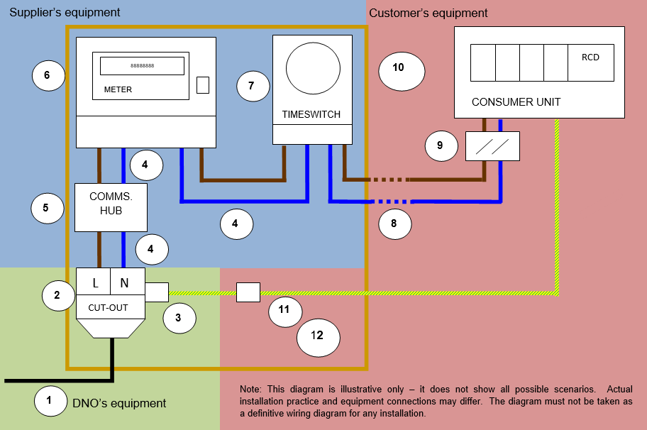

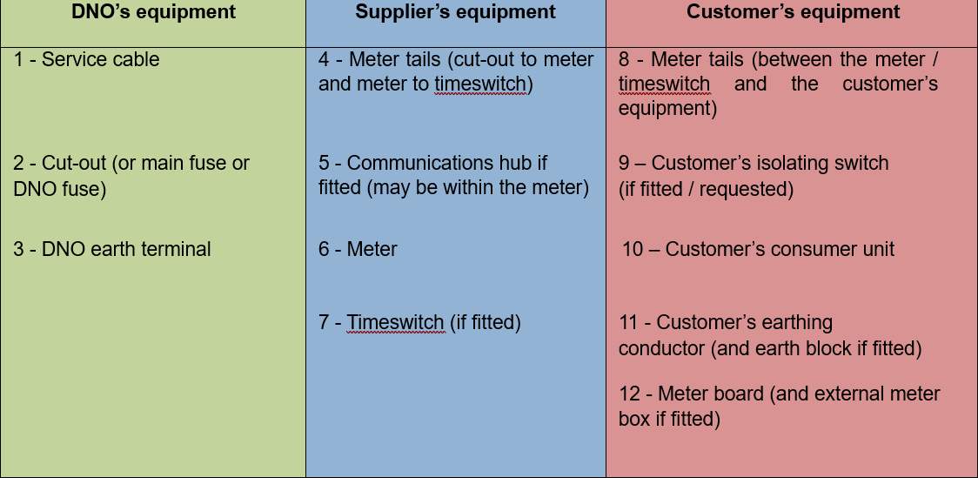

Flow Chart

You identify an issue at the
metering

service

position,

which
relates to
DNO

equipment.

Does the issue pose a
danger?

i.e. does it pose
an immediate risk to you,
the

customer,

or

members
of

the

public

or

damage

to
property?

Yes

Refer to Category A
Codes

–

Emergency

Pages

12

-

32

No

Does

the

condition

of

the
D
NO

equipment

require

the
D
NO

to take action
before you can install
and energise the meter?

Yes

Refer to Category B
Codes

–

Remedial

work

Pages

33

-

48

No
Can you complete your
work, but know that the
issue/information

should
be reported to the
D
NO
?

Yes

Refer

to

Category

C
Codes
–

Asset
issue/information
Pages 49
-

69

No

The issue is outside the scope of
this guide and should be
reported/managed

in

line

with

your
company’s internal procedures
(
e.g.

shared

fuses,

shared

neutrals
etc.)

List of Asset Condition Codes
The Codes are categorised as follows:
- Emergency Codes – an issue with the condition of the DNO equipment that poses a danger, including danger of death or injury to persons and/or danger of damage to or destruction of property. You must report these issues IMMEDIATELY to the DNO by telephone whilst you are on site. Refer to “Identifying the Distribution Business” in Appendix II for further details.

- Remedial Work Codes – an issue with the condition of the DNO equipment that prevents metering work (including meter installation/replacement) from being carried out but where the issue is not a category A issue. You must make the site safe and report these issues to the DNO using the data flow process.

- Asset Issue/Information Codes – an issue with/information on the DNO equipment that is neither a category A issue nor a category B issue. Report these characteristics to the DNO using the data flow process. It is not generally necessary to inform the customer of an Asset Issue/Information Code reported as this may create an unreasonable expectation of DNO intervention.
Colour coding helps to distinguish these categories – red for emergency, amber for remedial work and green for asset issue(s)/information.
Category A - Emergency

Code Description
A01 | DB equipment operating hot (signs of overheating)
A03 | Defective/weakened fuse carrier
A04 | Physical damage to DB equipment requiring immediate action
A05 | Sign of DB equipment burning, smoking or arcing
A07 | Exposed live conductor
A10 | DB earthing issue at existing installation which presents an immediate risk to Customer/MO
A12 | Damaged asbestos component in DB equipment
A14 | Polarity identified as incorrect at DB equipment
A15 | Immediate risk to the public or Customer due to current service position location
A17 | Live unearthed DB metal-encased equipment
A19 | Surface voltage found on plastic cut-out

Category B - Remedial work

Code Description
B01 | Fuse carrier welded in to cut-out base
B02 | Cut-out loose
B03 | Damaged/missing phase barrier in DB equipment
B04 | Damaged/broken cut-out terminal including missing terminal screws
B05 | Non-withdrawable fuse by design
B07 | DB equipment issue preventing installation/replacement of meter tails
B08 | Unhinged metal cut-out cover over un-insulated conductor
B10 | Unearthed DB metal-encased equipment
B11 | Cut-out with a fused neutral
B12 | DB owned CT metering equipment issue

Category C - Asset issue/information

Code Description
C02 | Signs of bitumen compound leaking
C03 | Lower rating fuse or cut-out (less than 60A)
C06 | Metal-encased cut-out
C07 | DB equipment unable to be securely sealed
C11 | Asbestos component identified in DB equipment
C14 | Fed from distribution board – local/remote from meter
C15 | DB cable terminating into DB equipment is VIR/MICC
C16 | DB equipment mounted on asbestos board
C17 | Black plastic cut-out
C18 | Rewirable cut-out fuse
C19 | Single insulated DB conductor (phase or non-PME neutral)
C20 | Missing combined neutral-earth cover on DB equipment
C21 | Non-standard PME connection arrangement

Category A Issues
Emergency Codes – an issue with the condition of the DNO equipment that poses a danger, including danger of death or injury to persons and/or danger of damage to or destruction of property. You must report these issues IMMEDIATELY to the DNO by telephone whilst you are on site. Refer to “Identifying the Distribution Business” in Appendix II for further details.
In the interests of customer safety, for category A issues A01, A05, A10, A17 and A19 the Meter
Operative, upon identification of a defined issue, MUST NOT CONTINUE TO OPERATE THE DNO EQUIPMENT UNTIL THE ISSUE HAS BEEN RESOLVED BY THE DNO. Report by telephone IMMEDIATELY and REMAIN ON SITE until the DNO arrives.
For category A14 issues, the Meter Operative MUST REMAIN ON SITE, however due to the nature of this particular issue the Meter Operative may have to operate the DNO equipment prior to the DNO attending site.
For category A issues, A03, A04, A07, A12, and A15, it is permissible for the MOA to allow their Meter Operatives to undertake mitigating actions. The Meter Operative can install the meter and leave site after contacting the DNO and notifying them of the actions taken to mitigate any danger and whether the meter installation has been completed or not.
Any actions/work carried out by the Meter Operative at site shall be completed in accordance with their company policies and procedures.
If the Meter Operative does undertake mitigating actions and leaves site, a Category A Customer Notification Card (or equivalent) (example in Appendix III) should be left. This is to advise the customer to expect communication from the DNO within the next few hours to inspect their equipment and carry out any necessary repairs.
Only one Code should be reported per MPAN. Where there are multiple DB related issues at one MPAN, report the most serious one using the relevant Code. When reporting a category A issue mention any additional issues to the DNO call agent.
When reporting a category A (emergency) issue, you must always identify yourself as a MOA and that you want to report a category A (emergency) issue. You should be asked to provide the following information:
- Your full name;
- Your contact telephone number;
- The customer’s name and contact number;
- Any relevant customer priority service register (vulnerability) status (see Appendix IV for categorisation of a vulnerable customer);
- The Code of the most serious defect being reported;
- Any secondary defects and relevant information;
- The status of the supply;
- Location of defect, i.e. address including postcode;
- Meter Point Administration Number (MPAN);
- Who you are working for;
- The registered Supplier for the property;
- Whether the work is associated with the installation of a Smart meter;

- Whether the work is associated with a “gas first” Smart meter installation;
- Whether you are leaving site or not;
- Where further evidence, such as photographs may assist the DNO, you may be requested to provide such support.
When you report an issue by telephone you will be provided with a unique job reference number by the DNO Emergency Contact Centre on the same call.

Category A – Emergency
Immediately report to the DNO by telephone and remain on site until the DB arrives
Asset Condition Code: A01 | Code Description:  DNO equipment operating hot (signs of overheating)

Description:
The DNO cut-out/distribution board or service cable is operating hot and/or showing signs of overheating. This might be due to overload on the customer side, or internal problems within the equipment. Signs include:
- Visual signs of the cut-out or service cable overheating;
- Equipment may smell and be giving off fumes;
- If it is an older type of cable (e.g. paper/lead) it may be discharging an oily substance
- Cut-out leaking bitumen/compound. If you see evidence of minor historic issues do not report A01 and instead report as Code C02;
- Signs of distortion in casing or darkened areas on the outside (modern cut-out).
Actions:
- Do not continue to operate the DNO equipment until the issue has been resolved by the DNO;
- Keep the immediate area clear of obstructions and keep everyone at a safe distance;
- If the cause appears load-related, advise the customer to reduce their load as appropriate;
- Contact the DNO immediately by telephone – report as Code A01;
- Tell the DB what actions you have taken;
- Remain on site until the DNO staff arrive;
- Ensure that you have provided all the details to the DNO as specified in Section 5 Category A Issues;
- Continue to monitor the issue and inform DB if the situation deteriorates.

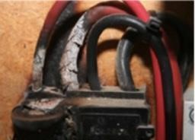
Cut-out with visual signs of overheating

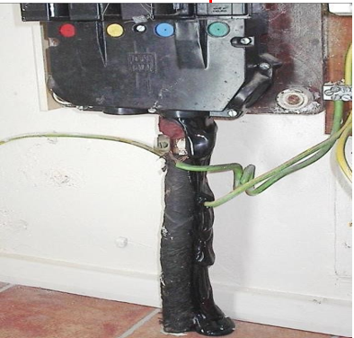

Bitumen
Bitumen has been used for many years to fill voids and seal joints in electrical equipment. It has a relatively low melting point, so bitumen leakage may indicate overheating. The cause of any leakage may be historic, e.g. if previous load patterns or the ambient temperature at the service position are very different to present day arrangements. Alternatively, the cause may be related to an ongoing issue. Recent dust and dirt on the bitumen may help you to distinguish between ongoing and historic issues.
When load is high, bitumen may become hot enough to soften and start to leak, often dripping onto the wall or floor below. Bitumen may also be softened by oils from an oil impregnated cable, which combines with the bitumen and causes it to leak.
If you have any immediate concerns, where the DNO equipment is showing serious signs of distress, refer to the actions above. If the DNO equipment is not hot but there is minor evidence of historic issues, report as Code C02.
Note: All electrical equipment will experience some degree of heating when current flows. This Code should be used when the heating is considered excessive – this will come down to operative experience. Equipment should not be touched to gauge the temperature, but radiated heat may be sensed. This should prompt more detailed checking for the conditions above.

Category A – Emergency
Immediately report to the DNO by telephone
Asset Condition Code: A03 | Code Description:  Defective/weakened fuse carrier

Description:
This code should be used when you inspect and/or remove the fuse carrier and upon assessment you conclude that the fuse carrier contacts are damaged, or inappropriately modified. These types of defects can cause overheating/arcing and signs of this may be observed on inspection.
Signs include:
- The fuse carrier does not fit firmly within the fuse carrier contacts – the fuse may be loose and may easily fall away;
- The contact in the DB equipment that the fuse inserts into may be broken, cracked or damaged and so overheating and arcing may occur;
- Heat discolouration and/or pitting of the fixed contact or carrier contact.
This Code should also be used to report instances such as:

- Where inappropriate materials (e.g. copper wire) are discovered in place of the correct fuse-wire or cartridge fuse (where it is not possible for the Meter Operative to replace);
- Incompatible fuse carrier used which has led to poor condition due to overheating and/or arcing.
- Incorrect screw(s) used to clamp fuse in carrier.
See the next page for a photo examples of above.
Where it is not safe to replace the fuse carrier which then leaves exposed live conductors, this must be reported as Code A07.
Actions:
- Do not restore the customer’s supply;
- Where possible and safe to do so:
For PLASTIC cut-outs:
- Remove the fuse from the fuse carrier;
- Replace the fuse carrier into the cut-out, to make the cut-out safe and remove exposure to live contacts;
- If there are no exposed parts, secure the empty fuse carrier using appropriate seals (as per CoMCoP Appendix 19).
For METAL-ENCASED cut-outs and distribution boards:
- Remove the fuse from the fuse carrier;
- Close the cut-out or distribution board cover and re-seal to ensure that the installation is secure.

In all cases:
- If you are remaining on site for the DNO to attend, keep the immediate area clear of obstructions and keep everyone at a safe distance;
- Contact the DNO immediately by telephone – report as Code A03;
- Tell the DNO what actions you have taken, if any;
- Remain on site until the DNO staff arrive unless you have been able to take any mitigating actions to prevent danger in accordance with your company’s risk assessment policy (see note below);
- If you do undertake mitigating actions and leave site, leave a Category A Customer Notification Card (where available). This is to advise the customer to expect communication from the DNO within the next few hours to inspect their equipment and carry out any necessary repairs;
- If you are leaving site, ensure that you have informed the DNO that you are leaving;
- Ensure that you have provided all the details to the DNO as specified in Section 5 Category A Issues.

Category A – Emergency
Immediately report to the DB by telephone
Asset Condition Code: A04 | Code Description:  Physical damage to DNO equipment requiring immediate action

Description:
The DNO equipment is damaged e.g. broken or severely cracked/damaged cut-out casing or service cable that requires immediate action (see detailed guidance below).
Examples of damaged service cables include:
- Squashed / deformed service cables (e.g. the cable is squashed flat);
- Cables with severely damaged outer sheathing (e.g. where the conductor itself is visible). As the extent of the service cable damage is often unknown, severely damaged service cables should be reported as A04 regardless of the supply earthing arrangement.

Examples are shown in the photos below:

Severely damaged cut-out casing Severely damaged service cable

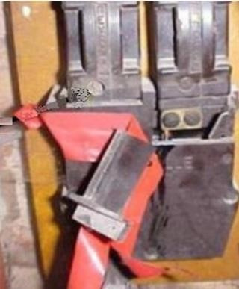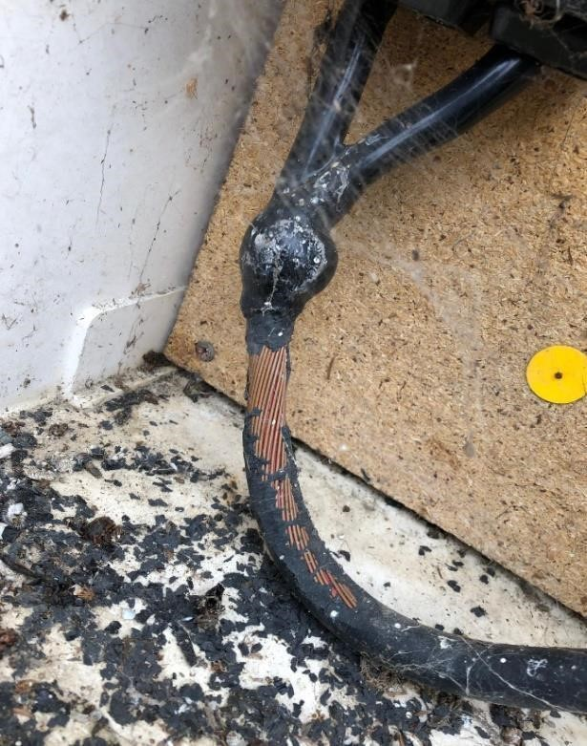

Circumstances where there are exposed live conductors should be reported as Code A07.
Damaged/broken hinges not presenting an immediate danger should be reported as Code B08 when it prevents metering work from being undertaken.

This Code SHOULD NOT be used to report missing/damaged earth/neutral-earth terminal access covers or removed knock-outs from a cut-out for the provision of an earth connection. Photo examples shown below:
PME cut-out damaged (but not requiring immediate action) with terminal exposed by missing cover – report as Code C20
Neutral- earth Knock out missing and the neutral-earth is exposed – do not report

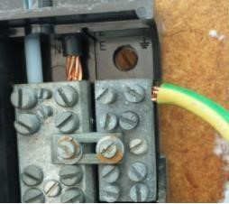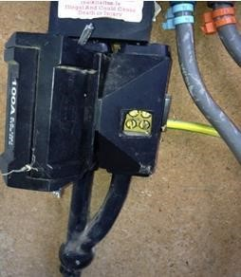

Actions:
- Do not continue to operate the DNO equipment – unless mitigating actions have been taken to allow work to continue;
- If you are remaining on site for the DNO to attend, keep the immediate area clear of obstructions and keep everyone at a safe distance;
- Contact the DNO immediately by telephone – report as Code A04;
- Tell the DB what actions you have taken, if any;
- Remain on site until the DNO staff arrive unless you have been able to take any mitigating actions to prevent danger in accordance with your company’s risk assessment policy (see note below);
- If you do undertake mitigating actions and leave site, leave a Category A Customer Notification Card (or equivalent). This is to advise the customer to expect communication from the DNO within the next few hours to inspect their equipment and carry out any necessary repairs;
- If you are leaving site, ensure that you have informed the DNO that you are leaving;
- Ensure that you have provided all the details to the DNO as specified in Section 5 Category A Issues.
Note: The DB recommends that you remain on site. If you leave site, leaving an unsafe situation, you may be breaching your legal obligations under the ESQCR with respect to, but not limited to, (Duty of Cooperation - Part 1, Section 4). You may also be liable for any damage or injury caused as a result of not remaining on site to allow the DNO to gain access.

If you choose to leave site, it should be in strict adherence with your company’s risk assessment policy. This needs to take into account that by leaving site the DNO may not gain access for an
unspecified period of time and you may be taking responsibility for the electrical safety associated with this work until such time as the DNO gains access

Category A – Emergency
Immediately report to the DNO by telephone and remain on site until the DB arrives
Asset Condition Code:  A05 | Code Description:  Sign of DNO equipment burning, smoking or arcing

Description:
Burning or smoking or audible sound of arcing from the DNO equipment indicate that there is a severe problem with the equipment and action must be taken immediately.
Actions:
- Do not continue to operate the DNO equipment until the issue has been resolved by the DNO;
- Keep the immediate area clear of obstructions and keep everyone at a safe distance;
- If the cause appears load-related, advise the customer to reduce their load as appropriate;
- Contact the DNO immediately by telephone – report as Code A05;
- Tell the DNO what actions you have taken;
- Remain on site until the DNO staff arrive;
- Ensure that you have provided all the details to the DNO as specified in Section 5 Category A Issues;
- Continue to monitor the issue and inform DNO if the situation deteriorates.

Category A – Emergency
Immediately report to the DNO by telephone
Asset Condition Code: A07 | Code Description:  Exposed live conductor

Description:
This Code should be used for reporting exposed live conductors or terminals only when associated with DNO equipment; this means:
- Reporting exposed phase conductors;
- Reporting exposed neutral conductors associated with non-PME supplies;
- Reporting broken fuse carriers with access to live conductors.
Examples of what is reportable and is not reportable are shown in the photos below as well as the section ‘Explanation of earthing arrangements’.
Photo examples – Exposed conductors
These are examples of cut-outs showing visible bare conductors from the cable termination to the fuse unit.

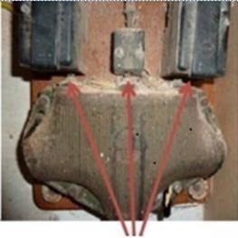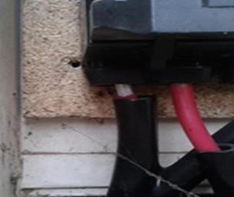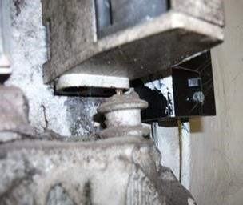

Visible

bare

conductors

Exposed

live

conductor

where
the insulated trousers have
Visible

bare

conductors

slipped exposing the live conductor

Code A07 SHOULD NOT be used where:
- Earth terminals are exposed by design (e.g. some distribution boards and cut-outs have external earth terminals or where cut-outs have knock-outs for the provision of an earth connection);
- Combined neutral-earth conductors or terminals forming part of the cut-out or the incoming service cable are exposed (not by design). Report as Code C20;
- The cut-out structure may be defective but live terminals are undisturbed and cannot be touched or interfered with without using tools. This should be reported under the appropriate Code e.g. C20 or C07;
- There are missing combined neutral-earth covers. Report as Code C20;
- There are issues with designed access points to protection chambers, but the live conductors or terminals cannot be touched or interfered with without using tools etc;

- Blanking plugs are missing from meter tail access points – these access points should be made safe by the Meter Operative;
- The installed meter tails do not completely fill the cable entry access on the DNO equipment. In these situations, it is the responsibility of the Meter Operative to take appropriate remedial action which may include in the first instance to re-terminate the meter tails. Other options which should be considered include the use of an appropriate sealant, grommets and/or security/safety collars where appropriate;
- A meter position change would create a potential category A issue that was not previously present and cannot be rectified by the Meter Operative e.g. changing the location of a meter which would expose live conductors in the cut-out that were previously covered by the meter. In this situation the meter position must not be altered and the issue reported as Code B07. To ensure the DNO is aware of why a seemingly serviceable cut-out should be replaced, it is important to state the reason why in the free text field;
- Any live single insulated DNO service conductor does not have any other mechanical protection provided. This type of issue should be reported as Code C19.
Examples of non-reportable events taking account of the earthing arrangement
Where cut-outs have missing ‘knock outs or earth terminal access covers’ as shown below; these SHOULD NOT be reported under any Code as they are specifically designed to provide access to the earth terminal.

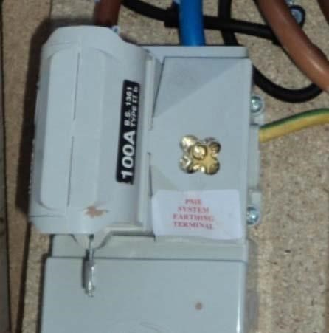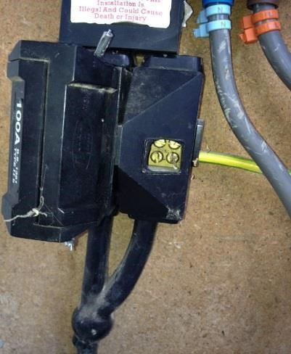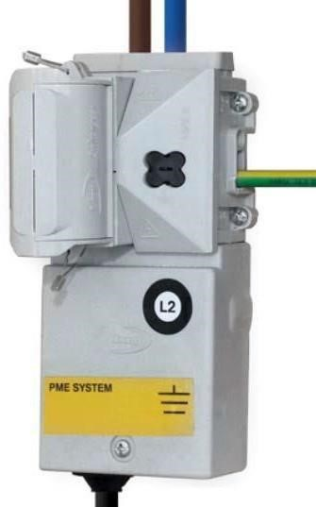
Earth

terminal

cover

in

place

Earth

terminal

cover

missing

and

the

neutral
-
earth

is

exposed

–

do not report

Knock

out

missing

and

the

neutral
-
earth

is

exposed

–

do
not report

Actions:
- Do not continue to operate the DNO equipment – unless mitigating actions have been taken to allow work to continue;
- If you are remaining on site for the DNO to attend, keep the immediate area clear of obstructions and keep everyone at a safe distance;
- Contact the DNO immediately by telephone – report as Code A07;
- Tell the DNO what actions you have taken, if any;
- Remain on site until the DNO staff arrive unless you have been able to take any mitigating actions to prevent danger in accordance with your company’s risk assessment policy (see note below);

- If you do undertake mitigating actions and leave site, leave a Category A Customer Notification Card (or equivalent). This is to advise the customer to expect communication from the DNO within the next few hours to inspect their equipment and carry out any necessary repairs;
- If you are leaving site, ensure that you have informed the DNO that you are leaving;
- Ensure that you have provided all the details to the DNO as specified in Section 5 Category A Issues.
Note: The DNO recommends that you remain on site. If you leave site, leaving an unsafe situation, you may be breaching your legal obligations under the ESQCR with respect to, but not limited to, (Duty of Cooperation - Part 1, Section 4). You may also be liable for any damage or injury caused as a result of not remaining on site to allow the DNO to gain access.
If you choose to leave site, it should be in strict adherence with your company’s risk assessment policy. This needs to take into account that by leaving site the DNO may not gain access for an unspecified period of time and you may be taking responsibility for the electrical safety associated with this work until such time as the DNO gains access.

Explanation of earthing arrangements
The vast majority of earthing arrangements encountered in the UK will be TN-S (SNE), TN-C-S (PME) or TT.

TN-S (SNE) earthing arrangement
This is where the service cable has a separate neutral and earth (SNE) conductor at the service position. The earth is usually provided by the metallic cable sheath or a dedicated conductor as part of the cable design. Examples shown below are for presentation purposes only which includes intentional removal of the terminal crutch covers.

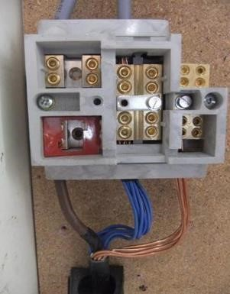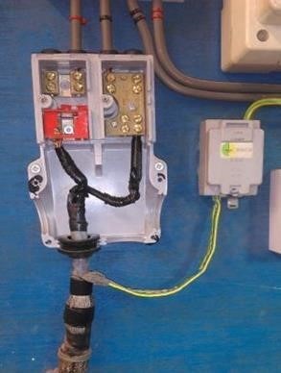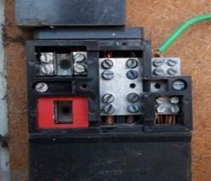
SNE arrangement
-

note
that the link is
removed to
provide

separate

neutral

and
earth connection

TN-C-S (PME) earthing arrangement
This is where the service has a combined neutral and earth conductor terminated at the service position and bonded to the customer’s installation or in the case of new supplies, is ready for

connection. Examples shown below are for presentation purposes only which includes intentional removal of the terminal and crutch covers.

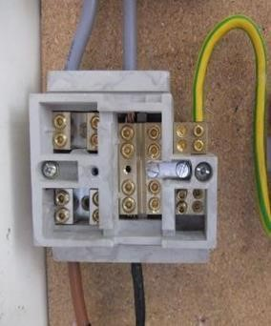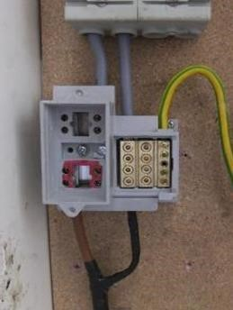
PME

arrangement

-

note

separate

neutral

and

earth

block

with

link

inserted

to

create

PME

connection

arrangement

PME

arrangement

-

note

single

connection

point

for

both

neutral

and

earth

conductors

TT earthing arrangement
This is where the DNO DOES NOT provide an earth connection via their DB equipment and is normally recognised by the lack of any earth connection to the incoming supply cable or cut-out.

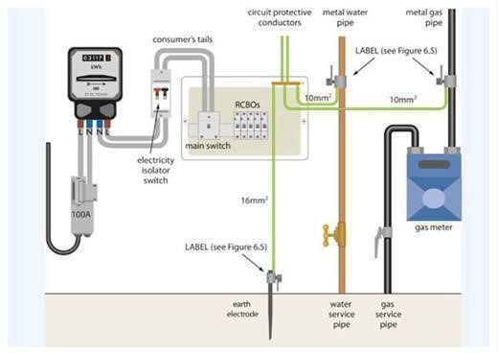

Category A – Emergency
Immediately report to the DNO by telephone and remain on site until the DNO arrives
Asset Condition Code: A10 | Code Description:  DNO earthing issue at existing installation which presents an immediate risk to Customer/MO

Note:
This Code does not relate to the provision of new earthing facilities. Requests for new earthing connections follow a different process: they should be applied for by the customer or their representative.
Description:
There is an immediate risk to the customer due to deterioration of, or damage to, an earth terminal provided by the DNO. For example, there is clearly a DNO earth terminal used to protect the customer’s installation, but you have reason to believe that it is ineffective (e.g. high earth loop impedance) OR the DNO earth has been previously provided but has been removed or become otherwise defective.
Examples of reasons for believing the earthing is ineffective include:
- A nil/low/intermittent lamp glow with test lamps (phase-earth terminal); • A loose earth clamp (do not attempt to tighten);
- Severely corroded DNO earth connection.
Where there are earthing problems with the customers’ installation, notify the customer, who may need to ensure an electrician attends to check their installation.
Note: Live unearthed DNO metal-encased equipment should be reported as Code A17. Report unearthed but NOT LIVE DNO metal-encased equipment as Code B10.
Actions:
- Identify whether this is an issue to report to the DNO or to discuss with the customer (see guidance below). If it is a DNO issue:
- Do not continue to operate the DNO equipment until the issue has been resolved by the DNO;
- Keep the immediate area clear of obstructions and keep everyone at a safe distance;
- Contact the DNO immediately by telephone – report as Code A10;
- Tell the DNO what actions you have taken, if any;
- Remain on site until the DNO staff arrive;
- Ensure that you have provided all the details to the DNO as specified in Section 5 Category A Issues.
Guidance: Is this a DNO or customer issue? It is always the customer’s responsibility to make sure that their installation is effectively earthed. Any concerns over whether their installation has been effectively earthed (e.g. shocks from light switches or broken or missing leads) must be raised with the customer.

Many properties will never have used a DNO earth – so just because you cannot see an earth connection, does not mean that there is a problem. For example, many properties use their own earth stake with an earth leakage protective device.

For those properties where a DNO earth terminal has clearly been provided and was previously used by the customer’s electrician to provide a main earth, then:
- If the earth lead away from the DNO earth terminal is damaged, you must tell the customer; or
- If the DB earth terminal itself is damaged, you must ring the DNO immediately, reporting this under A10 (above).
In any case, if you think that there is no effective earth, switch off consumer unit(s) or isolator(s).
What other actions could I take?
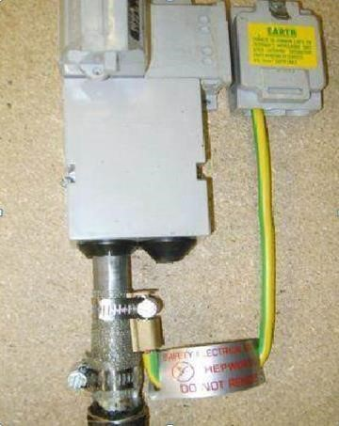
The photos below illustrate an earth connection using an earth clamp around the sheath of the service cable. If the clamp/connection is loose, do not tighten it, as this could potentially lead to cable damage and catastrophic failure. Loose earth connections attached to other parts of the DNO equipment e.g. on a terminal at the side of a cut-out, may be tightened.

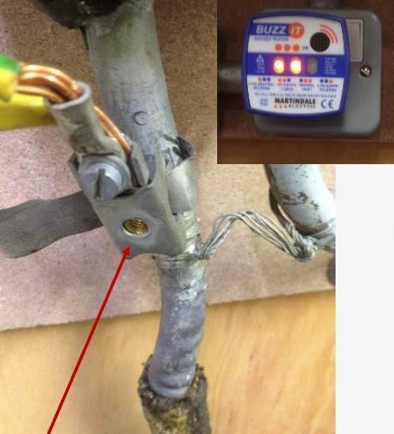
Socker tester indicates an earthing issue but further tests are required to confirm that the whole installation is not adequately earthed. If confirmed report as Code A10.
Screw missing from the earth clamp

Category A – Emergency
Immediately report to the DNO by telephone
Asset Condition Code: A12 | Code Description:  Damaged asbestos component in DNO equipment
Description:
There is asbestos in the DNO equipment (e.g. cut-out, distribution board) and it is damaged. If asbestos is present but not damaged, report as Code C11.
Note 1: Defects to asbestos meter boards that do not have DNO equipment attached should not be reported to the DNO.
Note 2: If the cut-out is mounted on an asbestos board you should report these to the DNO as Code C16.
Actions:
If you inspect the DNO equipment and discover that there is asbestos material in it, and it is damaged:
- Do not continue to operate the DNO equipment;
- If you are remaining on site for the DNO to attend, keep the immediate area clear of obstructions and keep everyone at a safe distance;
- Contact the DNO immediately by telephone – report as Code A12;
- Tell the DNO what actions you have taken, if any;
- Remain on site until the DNO staff arrive unless you have been able to take any mitigating actions to prevent danger in accordance with your company’s risk assessment policy (see note below);
- If you do undertake mitigating actions and leave site, leave a Category A Customer Notification Card (or equivalent). This is to advise the customer to expect communication from the DB within the next few hours to inspect their equipment and carry out any necessary repairs;
- If you are leaving site, ensure that you have informed the DNO that you are leaving;
- Ensure that you have provided all the details to the DNO as specified in Section 5 Category A Issues.
An AMO document “Guidance to manage asbestos during metering activities” provides guidance to companies in developing their own asbestos safe working procedures. This will allow your company to update their asbestos procedures, which you must follow in the event of encountering asbestos- based materials.
Note: The DNO recommends that you remain on site. If you leave site, leaving an unsafe situation, you may be breaching your legal obligations under the ESQCR with respect to, but not limited to, (Duty of Cooperation - Part 1, Section 4). You may also be liable for any damage or injury caused as a result of not remaining on site to allow the DNO to gain access.
If you choose to leave site, it should be in strict adherence with your company’s risk assessment policy. This needs to take into account that by leaving site the DNO may not gain access for an unspecified period of time and you may be taking responsibility for the electrical safety associated with this work until such time as the DNO gains access.

Category A – Emergency
Immediately report to the DNO by telephone and remain on site until the DNO arrives
Asset Condition Code: A14 | Code Description:  Polarity identified as incorrect at DNO equipment

Description:
You discover incorrect polarity on the incoming service cable to the DNO equipment when you are carrying out the polarity check.
Any cross polarity beyond the outgoing side of the DNO equipment is the responsibility of the MOA or customer dependent upon the point at which the cross polarity is identified. Follow your company policy.
Note: In certain situations, exposed metal work may still be live (and remain live with the fuse removed) and this should be part of your risk assessment when making the site safe. Isolating the customer’s supply by switching off the consumer unit/double pole isolator or removing the cut-out fuse could leave the customer’s installation in a less safe condition than before.
Actions:
- Consider whether other customers may be affected e.g. due to a shared or looped service and advise DNO of this when making your report;
- Re-insert the fuse into the cut-out if you have removed it;
- Switch the consumer unit/double pole isolator back on if you have switched it off as part of your work;
- Do not continue to operate the DNO equipment until the issue has been resolved by the DNO;
- Contact the DNO immediately by telephone – report as Code A14;
- Tell the DNO what actions you have taken;
- Remain on site until the DNO staff arrive;
- Ensure that you have provided all the details to the DNO as specified in Section 5 Category A Issues.

Category A – Emergency
Immediately report to the DNO by telephone
Asset Condition Code: A15 | Code Description:  Immediate risk to the public or Customer due to current service position location

Description:
You discover that the service position is unsafe and poses an immediate risk to the customer or public. Examples of unsafe locations and situations include:
- Service position insecure or exposed to immediate weather damage;
- In a shower, wet area or bathroom;
- In a flooded cellar;
- Where there is a flammable environment or an explosive atmosphere, which cannot be addressed by the customer;
- Near a car jet washing facility that is not adequately separated;
- In close proximity to machinery, making it unsafe to work on the service;
- Where the structure to which the service is attached is in danger of collapse;
- Buildings that are not secure against third party access, e.g. abandoned warehouses;
- Where the DNO equipment has become detached and is hanging unsupported from its normally secured position.
Note: Where the DNO equipment is loose on the meter/backboard and in such a condition that you cannot safely rectify the issue report as Code B02.
Actions:
- Do not continue to operate the DNO equipment – unless mitigating actions have been taken to allow work to continue;
- If you are remaining on site for the DNO to attend, keep the immediate area clear of obstructions and keep everyone at a safe distance;
- Contact the DNO immediately by telephone – report as Code A15;
- Tell the DNO what actions you have taken, if any;
- Remain on site until the DNO staff arrive unless you have been able to take any mitigating actions to prevent danger in accordance with your company’s risk assessment policy (see note below);
- If you do undertake mitigating actions and leave site, leave a Category A Customer Notification Card (or equivalent). This is to advise the customer to expect communication from the DNO within the next few hours to inspect their equipment and carry out any necessary repairs;
- If you are leaving site, ensure that you have informed the DNO that you are leaving;
- Ensure that you have provided all the details to the DNO as specified in Section 5 Category A Issues.
Note: The DNO recommends that you remain on site. If you leave site, leaving an unsafe situation, you may be breaching your legal obligations under the ESQCR with respect to, but not limited to, (Duty of Cooperation - Part 1, Section 4). You may also be liable for any damage or injury caused as a result of not remaining on site to allow the DNO to gain access.

If you choose to leave site, it should be in strict adherence with your company’s risk assessment policy. This needs to take into account that by leaving site the DNO may not gain access for an unspecified period of time and you may be taking responsibility for the electrical safety associated with this work until such time as the DNO gains access.

Category A – Emergency
Immediately report to the DNO by telephone and remain on site until the DNO arrives
Asset Condition Code: A17 | Code Description:  Live unearthed DNO metal-encased equipment

Note:
All metalwork associated with the supply should be earthed. Although not ideal, metal-encased covers are generally considered earthed when attached to an earthed box.
Description:
Any circumstances on the site involving DNO equipment that has the potential for electric shock or electrocution, which has not been covered in other Codes, including live service or cut-out metalwork, and unearthed service metalwork (e.g. metal-encased cut-out, distribution board, cable gland box).
If unearthed DNO equipment is not live report as Code B10.
Actions:
- Do not continue to operate the DNO equipment until the issue has been resolved by the DB;
- Keep the immediate area clear of obstructions and keep everyone at a safe distance;
- Contact the DNO immediately by telephone – report as Code A17;
- Tell the DNO what actions you have taken;
- Remain on site until the DNO staff arrive;
- Ensure that you have provided all the details to the DNO as specified in Section 5 Category A Issues;
- Continue to monitor the issue and inform DNO if the situation deteriorates.

Category A – Emergency
Immediately report to the DNO by telephone and remain on site until the DNO arrives
Asset Condition Code: A19 | Code Description:  Surface voltage found on plastic cut-out

Description
A potential safety issue has been identified with both single and three phase black plastic cut-outs (potentially constructed from phenolic materials), installed by DNOs across the UK between 1967 and 1992. Under certain conditions/circumstances the plastic casing can become conductive leading to a risk of electric shock and/or equipment failure.
If as part of your risk assessment of the work area, you identify that the cut-out is constructed of a black plastic material then follow the actions below as required.
If no sustained voltage, is identified on a black plastic cut-out whilst carrying out your work, report as Code C17.
Stage 1 Actions:
- Before the operation of a black plastic cut-out check for sustained surface voltage on the body and fuse carrier of the cut-out;
- You must not use a proximity voltage indicator at any stage of the assessment process;
- You must use an appropriate direct contact voltage measuring device to identify the presence of surface voltage;
- Before reporting to the DNO, readings from a single point of contact voltage indicator must be confirmed by a second test using an approved two-pole testing device to confirm the presence of sustained voltage;
- If no sustained voltage is identified, proceed to Stage 2;
- If a sustained voltage is identified, stop work and proceed to Stage 3.
- If you are uncertain on the interpretation of your tests, contact your supervisor for further advice;
Stage 2 Actions:
- With the fuse carrier and any cover plate removed, check for sustained surface voltage on the fixing back-plate between the incoming phase and neutral including any fixing screws;
- Any testing shall be completed using the devices mentioned in Stage 1;
- If no sustained voltage is identified, continue with your work;
- If a sustained voltage is identified, stop work and proceed to Stage 3.
Stage 3 Actions (Reporting to the DNO):
- Do not continue to operate the DNO equipment until the issue has been resolved by the DNO;
- Keep the immediate area clear of obstructions and keep everyone at a safe distance;
- Contact the DNO immediately by telephone - report as Code A19;
- Tell the DNO what actions you have taken, confirming that a sustained surface voltage has been detected;
- Remain on site until the DNO staff arrive;
- Ensure that you have provided all the details to the DNO as specified in Section 5 Category A Issues;

- Continue to monitor the issue at a safe distance and inform the DNO if the situation deteriorates.

Black plastic cut-out
Cut-outs such as these can be constructed of a phenolic material:

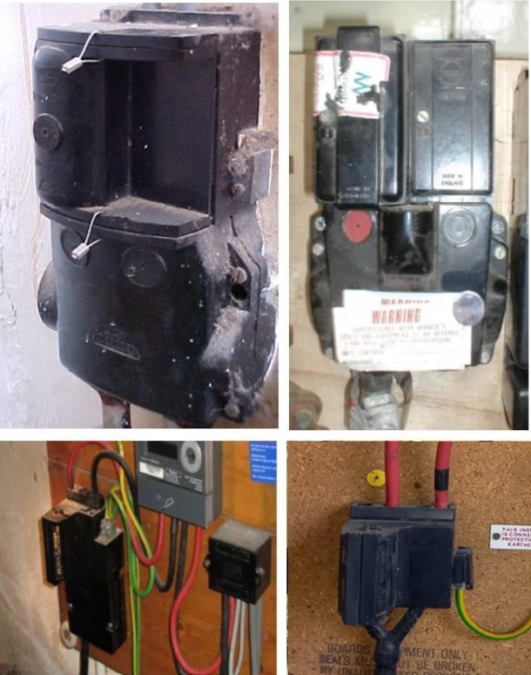
Testing of the cut-out surface with two-pole voltage testing device to confirm the existence of sustained voltage.

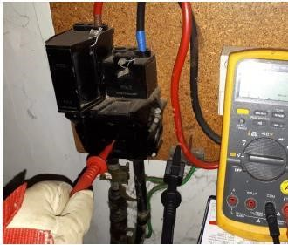

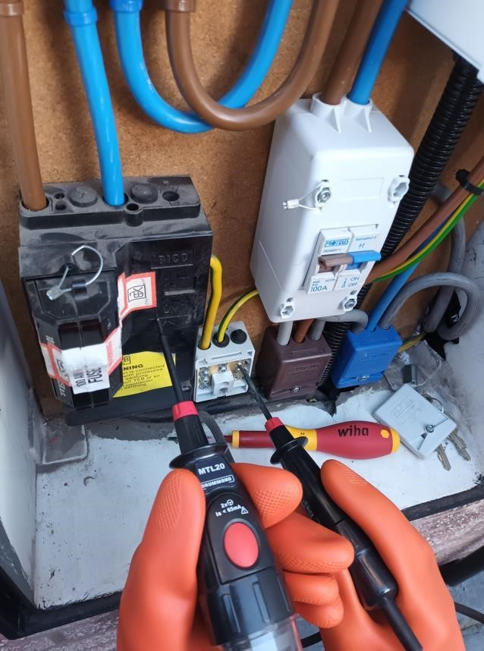

Category B Issues
Remedial Work Codes – an issue with the condition of the DNO equipment that prevents metering work (including meter installation/replacement) from being carried out but where the issue is not a category A issue. You must make the site safe and report these issues to the DNO using the data flow process.
Any actions/work carried out by the Meter Operative at site shall be completed in accordance with their company policies and procedures.
Category B Code MUST ONLY be reported when the issue prevents you from installing the meter.
Where there are multiple DNO related issues at one MPAN, report the most serious one using the relevant Code. Report the additional issues using the free text field.
Only report one Code per MPAN e.g. a B Code data flow SHOULD NOT be sent if a category A issue has been reported by telephone.
Before commencing work the Meter Operative must ensure that they have all the necessary tools and equipment to complete their task and leave the DNO equipment in a safe and serviceable condition.
In the case where an issue is both a Code B11 (cut-out with a fused neutral) and also another B Code, report the prime Code as a B11 with reference made to other issues in the free text field.
You must seek to resolve all problems within your remit.
Where a DNO equipment defect is noticed on adjacent DNO equipment to which the MOA is not appointed, the DNO should be contacted by telephone under business as usual processes.
In the case of all category B issues your actions should be:
- Wherever possible, for safety and security reasons ensure the DNO equipment is sealed before leaving site;
- Stop work and do not commence your meter installation activity;
- Report the issue to the DNO via the data flow system;
- Provide the DNO with the customer’s name and contact number using the data flow system;
- To ensure the customer is fully aware of next steps, leave a Category B Customer Notification Card (or equivalent) to advise the customer to expect communication from the DNO requesting an appointment to visit site to inspect the DNO equipment.
In certain circumstances it may be helpful to the DNO to obtain a photograph of the condition being reported. Some DNOs may have a process to facilitate the transfer of imagery. If this is available details can be found within the DNO information for MOAs documents located on the REC Metering Hub.

Category B – Remedial Work
DNO work required for you to complete your work
Asset Condition Code: B01 | Code Description:  Fuse carrier welded in to cut-out base

Description:
On attempting to remove the DNO fuse, in any situation, you are unable to remove the fuse carrier safely. This could be due to corrosion, previous arcing or overheating. The carrier cannot be moved, and any further effort exerted could cause further damage to the DNO equipment.
Note: If you discover that an incompatible fuse carrier has been inserted into the cut-out or distribution board, report as Code A03.
If there are immediate signs of arcing or overheating report as Code A01.
Actions:
- Wherever possible, for safety and security reasons ensure the DNO equipment is sealed before leaving site;
- Stop work and do not commence your meter installation activity;
- Report the issue to the DNO via the data flow system – report as Code B01;
- Provide the DNO with the customer’s name and contact number using the data flow system;
- To ensure the customer is fully aware of next steps, leave a Category B Customer Notification Card (or equivalent) to advise the customer to expect communication from the DNO requesting an appointment to visit site to inspect the DNO equipment.

Fuse carrier welded into cut-out base

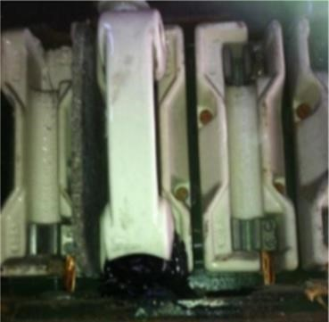
A fuse has become stuck due to bitumen compound rising up from the cable box beneath and “gluing” the fuse contacts

Category B – Remedial Work
DNO work required for you to complete your work
Asset Condition Code: B02 | Code Description:  Cut-out loose

Note:
During your risk assessment you may discover that the meter/backboard is in a loose or poor condition. You must seek to resolve all problems within your remit.
If you are satisfied that you CAN SAFELY MAKE THE DB EQUIPMENT AND METER SECURE, you may decide to proceed with your work, in which case do not report.
Description:
Examples of environments where this Code may be used are situations where damp environments,
e.g. cellars, sheds or alleyways have resulted in the meter/backboard decaying and the DNO equipment has become loose.
If the DNO EQUIPMENT IS INSECURE and that continuing with your work may result in damage to equipment or risk to yourself, a visit is required by the DNO to re-fix their equipment before you can proceed with your work, report as Code B02.
Note: If the condition puts the customer or public at immediate risk report as Code A15.
Actions:
- Wherever possible, for safety and security reasons ensure the DNO equipment is sealed before leaving site;
- Stop work and do not commence your meter installation activity;
- Report the issue to the DNO via the data flow system – report as Code B02;
- Within the free text field on the data flow, please identify what equipment is located on the meter/backboard (including any customer equipment);
- Provide the DNO with the customer’s name and contact number using the data flow system;
- To ensure the customer is fully aware of next steps, leave a Category B Customer Notification Card (or equivalent) to advise the customer to expect communication from the DNO requesting an appointment to visit site to inspect the DNO equipment.

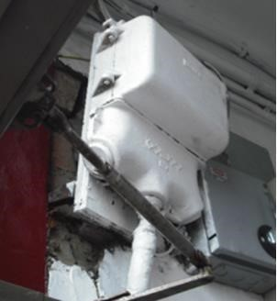
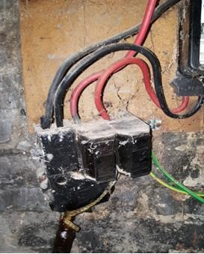
Examples of a cut-out that is clearly not securely fixed onto a wall

Category B – Remedial Work
DNO work required for you to complete your work
Asset Condition Code: B03 | Code Description:  Damaged/missing phase barrier in DNO equipment

Description:
Internal barriers/covers between phases or phase and neutral or phase and earth metalwork are: • Significantly damaged (i.e. they cannot perform their function); or
- Missing from the cut-out or other DNO equipment.
This will prevent you from removing the fuse, or fuses, safely.
If you suspect that the damaged phase barriers are an asbestos material then report as Code A12.
If the equipment is not damaged, but contains asbestos components then report as Code C11.
Actions:
- Wherever possible, for safety and security reasons ensure the DNO equipment is sealed before leaving site;
- Stop work and do not commence your meter installation activity;
- Report the issue to the DNO via the data flow system – report as Code B03;
- Provide the DNO with the customer’s name and contact number using the data flow system;
- To ensure the customer is fully aware of next steps, leave a Category B Customer Notification Card (or equivalent) to advise the customer to expect communication from the DNO requesting an appointment to visit site to inspect the DNO equipment.
Examples of cut-outs with removable phase barriers:
Cut-out designs are reliant on a form of phase barrier. In some designs of cut-outs the phase barrier is removable to allow easier access to terminals. The below images are examples of a cut-out with missing phase barriers – you should note that there are many other types of metal-encased cut-outs with similar internal arrangements.

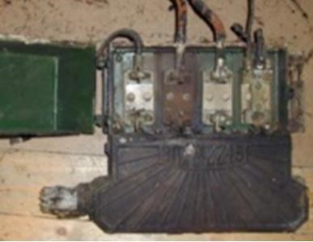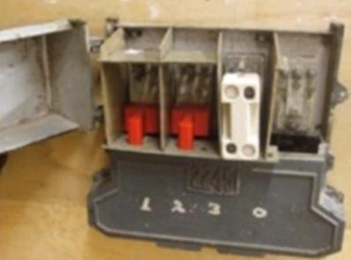

Missing

phase

barriers.

Note

the

proximity

of
the incoming “stalks” to the metal cover

Missing

phase

barrier.

Shrouds

in
(

red)

have

been

used

by

the

Meter

Operative

to

cover

the
live terminals

Category B – Remedial Work
DNO work required for you to complete your work
Asset Condition Code: B04 | Code Description:  Damaged/broken cut-out terminal including missing terminal screws

Description:
Following removal of the DNO fuse and neutral or neutral/earth cover it is clear that the condition of the outgoing phase and neutral connections will prevent metering work being undertaken.
This will include where terminal screws are missing, but ONLY where spare ways aren’t available or where there is more than one outgoing cable terminal and only one has missing screws you should proceed with your work by either; using the terminal that is complete or by utilising screws from an unused terminal.
If a terminal screw is found sheared off and unable to be removed but the cable is found fit for purpose and shows no signs of overheating; it can be assumed it sheared off when being fully tightened and you should not report a defect to the DNO.
Should meter tails need to be changed and screw is found to be sheared off and can’t be removed cease work and report as Code B04.
The screws are designed to be tightened by hand with the appropriate sized screwdriver or tool. If in the course of tightening you shear the screw you may be using excessive force and the screw will be adequately tight. These would not need to be reported under this Code.
If during the course of your works you shear off a termination screw and you cannot confirm tightness report as Code A01 and remain on site for the DNO to attend.
Note: In circumstances where spare screws and terminals can be utilised the meter exchange can take place and you should not report a defect to the DNO, providing any redundant entry points can be made safe, e.g. by insertion of a blanking plug.

Examples:

Missing screw. Meter Operative Screw sheared off. Meter able to continue with work - do Operative able to continue with
not report work - do not report
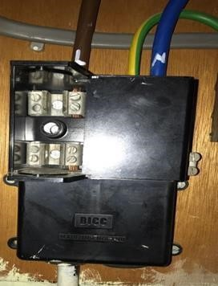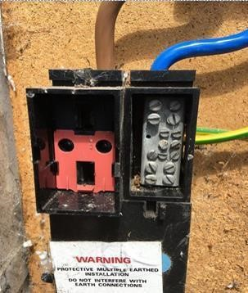

Actions:
- Wherever possible, for safety and security reasons ensure the DNO equipment is sealed before leaving site;
- Stop work and do not commence your meter installation activity;
- Report the issue to the DNO via the data flow system – report as Code B04;
- Provide the DNO with the customer’s name and contact number using the data flow system;
- To ensure the customer is fully aware of next steps, leave a Category B Customer Notification Card (or equivalent) to advise the customer to expect communication from the DNO requesting an appointment to visit site to inspect the DNO equipment.

Category B – Remedial Work
DNO work required for you to complete your work
Asset Condition Code: B05 | Code Description:  Non-withdrawable fuse by design

Note:
This Code should not be used in circumstances where the withdrawal of the cut-out fuse is prevented by an external obstruction such as built-over cupboard etc. Description:
Any cut-out where the equipment is designed such that the fuse cannot be removed for isolation purposes. Cut-outs with non-withdrawable fuses, or exposed live carrier screws, must not be worked on, as the only way to “operate” the cut-out is to work directly on the live terminals.
Note that in all cases a cut-out with a fused neutral should be reported as Code B11.
Actions:
- Wherever possible, for safety and security reasons ensure the DB equipment is sealed before leaving site;
- Stop work and do not commence your meter installation activity;
- Report the issue to the DNO via the data flow system – report as Code B05;
- Provide the DNO with the customer’s name and contact number using the data flow system;
- To ensure the customer is fully aware of next steps, leave a Category B Customer Notification Card (or equivalent) to advise the customer to expect communication from the DNO requesting an appointment to visit site to inspect the DNO equipment.
Examples – Non-withdrawable fuses
The photos below show an example of a cut-out where the fuse wire terminals are attached to the cutout, hence the fuse is non-withdrawable by design. Although note that this particular cut-out also contains a fused neutral and would therefore be reported under as Code B11.
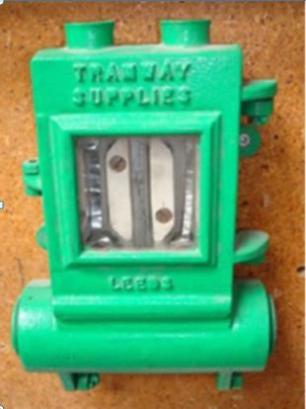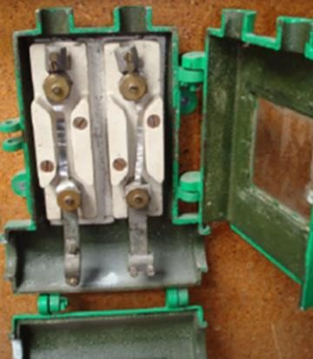

Further Example – Non-withdrawable fuses
The photos below show an example of a cut-out where the fuse carriers can only be withdrawn by loosening the live screws integral to the porcelain carriers. This is considered live working and is not within the scope of Meter Operative activity.

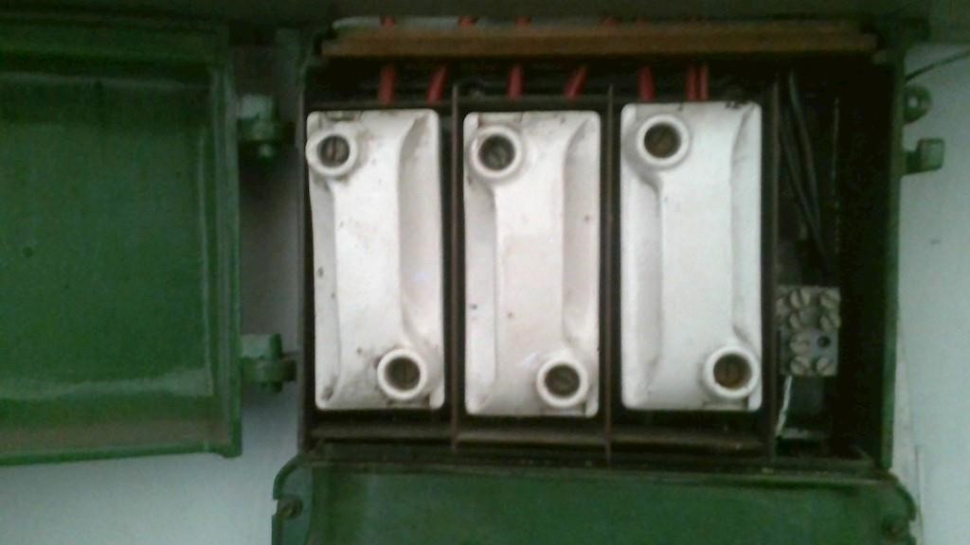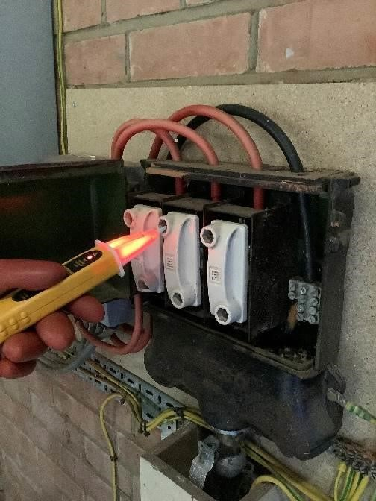

If the withdrawal of the above fuse carrier types is required to continue with your work, you should report the issue to the DNO via Code B05. The DNO will decide to take one of the following actions:

- The DB will make arrangements with the Meter Operator for a simultaneous site visit for DNO staff to withdraw the fuse to enable safe working to continue. The DNO staff will re-insert the fuse when works have been completed. To enable this option to be followed-up, Meter Operators should provide their contact details when they report this code to the DNO.

- If space on site permits, the DNO may choose to install red-link cut-outs above the existing cutout to facilitate meter operator works in the future.

- The DB will make arrangements with the customer to attend site and replace the cut-out.

Category B – Remedial Work
DNO work required for you to complete your work
Asset Condition Code: B07 | Code Description:  DNO equipment issue preventing installation/replacement of meter tails

Note:
DO NOT use this Code:
- If you are not permitted by your company to work on metal-encased cut-outs. Report the issue to your supervisor as per your company procedures;
- For situations where a shared fuse or shared neutral exists. Such situations should be managed in accordance with your company’s procedures;
- Where the Meter Operative is not deemed to be competent to undertake the work, i.e. they are not trained to undertake specific work by their company e.g. operate/work on metal- encased cut-outs. This is a MOA issue and does not relate to DNO equipment;
- If you do not have the specific tools (e.g. crimper) needed to terminate the meter tails;
- Where the issue involves meter tails between the meter and the customer’s equipment and is not DNO related. These should be discussed with the customer.
Description:
The meter tail connection from the DNO equipment to the meter needs to be replaced. You require the intervention of the DNO in order to complete your work. Examples include:
- The connection terminals on the outgoing side of the cut-out are unable to accept a minimum conductor (tails) size of 16mm²;
- The connection in the DNO equipment is welded in;
- Terminal screws cannot safely be slackened (e.g. neither fixed nor temporary shrouds are available);
- Holes would be left in metal DNO equipment if the tails were to be exchanged and grommets or bushes to fill the entry point are not available;
- A meter position change that would create a potential category A issue that was not previously present and cannot be rectified by the Meter Operative e.g. changing the location of a meter which would expose live conductors in the cut-out that were previously covered by the meter (see example below);
- There are non-standard cable terminations in the DNO equipment e.g. 2 meter tails feeding separate properties in the same live port and no second live port available (excluding lugged connections, see note below);
Note: In some circumstances, it may be necessary to make a lugged connection if the DNO equipment requires it. If this is the case do not report to DNO and obtain the appropriate tools to make the connection;
- The incoming neutral is found to be wired directly to the meter with no termination at the cut- out (excludes supplies provided by rising mains and lateral services, see section below);
- The PME connection arrangement is non-standard as described in scenario 1 of Code C21. Where the meter neutral tail between cut-out and meter does not need to be replaced or you can safely replace it without altering the earthing arrangement, do not report as Code B07 but continue with your work and report as Code C21.

- There is (not immediately hazardous) debris within the cut-out or distribution board that poses a risk to its safe operation. Use Code A04 to report issues where hazardous debris provides an immediate risk.

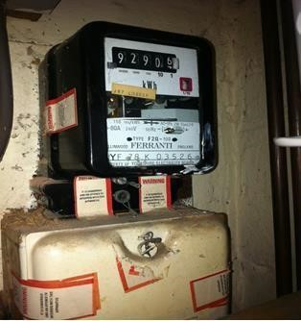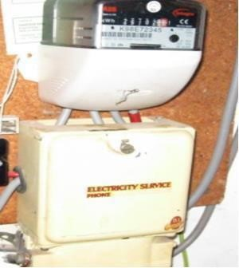

Raised

position

of

meter
could create a potential
category A issue by
leaving exposed live
conductor(s)

through

the
cut
-
out cable entry slot
that were previously
covered by the meter
placed

directly on

top

of
the cut
-
out

Rising Mains and Lateral Services
See also section 1.5.
Rising mains and lateral services are installed in all areas of GB and are used as a means of providing electricity supplies within multi occupancy buildings. The types of buildings which may have rising mains and lateral services installed within them may vary significantly ranging from buildings with as few as two individual properties to large multi storey buildings with hundreds of individual flats.
Defects should only be reported to the DNO where it is clear that they are responsible for the operation and maintenance of rising mains and lateral services within the property where a defect has been identified. If the DNO is not responsible for the operation and maintenance of rising mains and lateral services within the property a report will need to be sent to the Building Network Owner. If you are unsure regarding who a defect should be reported to contact your supervisor.
There are many different types of rising main and lateral service installations that have been installed across GB. The methods used will typically depend upon; the date of installation, the geographic location and the number of properties within the building. If you need further information regarding these installations contact your supervisor.
In modern installations it is common for isolation to be available adjacent to the meter.
For older installations there may be issues associated with supplies provided by rising main and lateral service installations that differ significantly from other types of supply. These may include:
- No isolation (fuse) or neutral connection (block) is available at the meter position, i.e. the lateral service connections are made direct into the meter;
- No isolation (fuse) is available at the meter position, i.e. the lateral service connections are terminated into connector blocks;
- Isolation is located remotely usually via a multi-phase cut-out or within a multi-service distribution board (BEMCO/ Ryfield etc.);
- Typical lateral service connections into the meter may include; o PVC/ XLPE single core cables; o VIR insulated single core cables; o MICC (pyro cables).

- Isolation is available at the meter position via a red link isolator or fuse unit but no separate neutral block.

Where isolation or neutral connections are not available at the meter position this should not prevent a Meter Operative from installing metering equipment. Refer to your own company’s procedures.
Note: In circumstances where the isolation point is located remote from the meter and can be identified, Meter Operatives should apply any isolation required and undertake their metering work.
Do not report these situations to the DNO as Code B07.
Where appropriate report as a category C Code, typically:
- C14 (Fed from distribution board – local/remote from meter)
- C15 (DNO cable terminating into DNO equipment is VIR/MICC)
- C21 (Non-standard PME connection arrangement)

Actions:
- Wherever possible, for safety and security reasons ensure the DB equipment is sealed before leaving site;
- Stop work and do not commence your meter installation activity;
- Report the issue to the DNO via the data flow system – report as Code B07. As this Code can be used for a variety of issues, to ensure the DNO is aware of why a seemingly serviceable cut-out should be replaced, it is important to state the reason why in the free text field;
- Provide the DNO with the customer’s name and contact number using the data flow system;
- To ensure the customer is fully aware of next steps, leave a Category B Customer Notification Card (or equivalent) to advise the customer to expect communication from the DNO requesting an appointment to visit site to inspect the DNO equipment.

Category B – Remedial Work
DNO work required for you to complete your work
Asset Condition Code: B08 | Code Description:  Unhinged metal cut-out cover over un-insulated conductor

Description:
There is a risk of flash-over where there are un-insulated live conductors and the removal/replacement of the cover is not effectively guided/controlled. For example, an uncommon type of pressed steel metal-encased cut-out (photo below), probably from the 1940s, is known to have this issue.
Examples of where Code B08 should be used, following INITIAL VISUAL INSPECTION, are:
- The cut-out or DNO distribution board cover is unhinged and it is of a type that it is known that un-insulated live conductors will be present;
- The cover hinges are damaged or broken.
Where the DNO equipment COVER HAS BEEN REMOVED and the following scenarios are identified, use the associated Code to report the issue/information:
- There is a potential risk of flash-over – report as Code A07;
- The hinges are discovered to be broken – report as Code A04;
- Phase barriers are not present or are damaged – report as Code B03;
- A healthy but unhinged metal-encased cut-out with phase barriers in place as designed – report as Code C06.
You can proceed with your work where the cut-out is unhinged and:
- The DNO equipment has adequately insulated live conductors; and
- There are insulated barriers in place, so that the DNO equipment cover cannot inadvertently come into contact with exposed un-insulated live conductors.
Actions:
- Wherever possible, for safety and security reasons ensure the DNO equipment is sealed before leaving site;
- Stop work and do not commence your meter installation activity;
- Report the issue to the DNO via the data flow system – report as Code B08;
- Provide the DNO with the customer’s name and contact number using the data flow system;
- To ensure the customer is fully aware of next steps, leave a Category B Customer Notification Card (or equivalent) to advise the customer to expect communication from the DNO requesting an appointment to visit site to inspect the DNO equipment.

Examples – Unhinged metal cut-out over uninsulated conductors
An uncommon type of pressed steel metal-encased cut-out, probably from the 1940s.

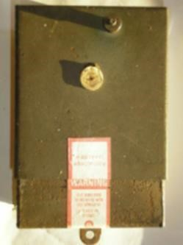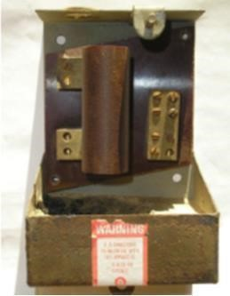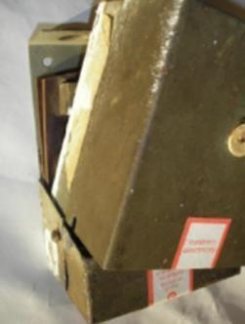

A typical example of a metal-encased cut-out which has known design deficiencies is the ISCO Type cut-out and extreme caution must be exercised when removing or replacing lids on this type of equipment. This particular example also had the phase barriers removed. All cut-outs must be assessed individually prior to attempting any live work on them ensuring that the phase barriers are in place.

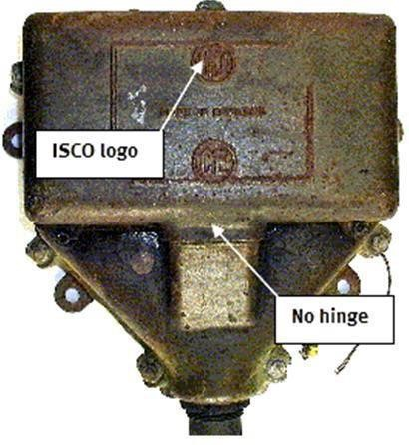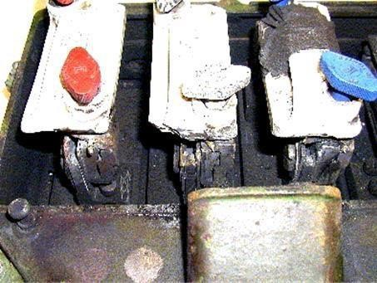

Category B – Remedial Work
DNO work required for you to complete your work
Asset Condition Code: B10 | Code Description:  Unearthed DNO metal-encased equipment

Description:
Any circumstances on the site involving DNO equipment that has been identified as unearthed and NOT LIVE (e.g. metal-encased cut-out casing). If live report as Code A17.
Note: If the DNO equipment which is unearthed is an immediate risk to safety you should report this issue as Code A10 and not this Code.
Actions:
- Wherever possible, for safety and security reasons ensure the DNO equipment is sealed before leaving site;
- Stop work and do not commence your meter installation activity;
- Report the issue to the DNO via the data flow system – report as Code B10;
- Provide the DNO with the customer’s name and contact number using the data flow system;
- To ensure the customer is fully aware of next steps, leave a Category B Customer Notification Card (or equivalent) to advise the customer to expect communication from the DNO requesting an appointment to visit site to inspect the DNO equipment.
Note:
All metalwork associated with the supply should be earthed. The earth connection can be checked with one probe of a test lamp connected to a phase. Although not ideal, metal-encased covers are generally considered earthed when attached to an earthed box.

Category B – Remedial Work
DB work required for you to complete your work
Asset Condition Code: B11 | Code Description:  Cut-out with a fused neutral

Description:
Any electricity service cut-out which, when opened, has fuse protection in both the phase and neutral ways. In most cases, these cut-outs will have been installed in pre-1937 properties.

The Electricity Safety, Quality and Continuity Regulations (ESQCR) states that, as of 31st January 2013, fused neutrals must not be retained. There is an HSE requirement for fused neutral cut-outs to be removed within 28 days of being identified.

If you encounter electricity service cut-out which you suspect has fuse protection in the neutral, do not proceed with your work. Make the area safe and immediately report the issue to the network operator via the data flow system as Code B11.

These are reportable as B11:
- Cut-outs with fuse wire installed making the neutral connection.
- Removeable carriers containing solid neutral links, but links are not visible or clearly marked.
These are not reportable as B11:
- Cut-outs with visible solid neutral links not in a carrier that do not pose a risk of accidentally removing before the fuse.
- Where fuse carriers which contain solid neutral links are clearly labelled (see label examples below).
- Private fused neutral equipment on BNO rising or lateral mains (see examples of DNO assets in photographs below).

Actions:
- Wherever possible, for safety and security reasons ensure the DB equipment is sealed before leaving site;
- Stop work and do not commence your meter installation activity;
- Report the issue to the DB via the data flow system – report as Code B11;
- Provide the DB with the customer’s name and contact number using the data flow system;
- To ensure the customer is fully aware of next steps, leave a Category B Customer Notification Card (or equivalent) to advise the customer to expect communication from the DB requesting an appointment to visit site to inspect the DB equipment.

Examples:
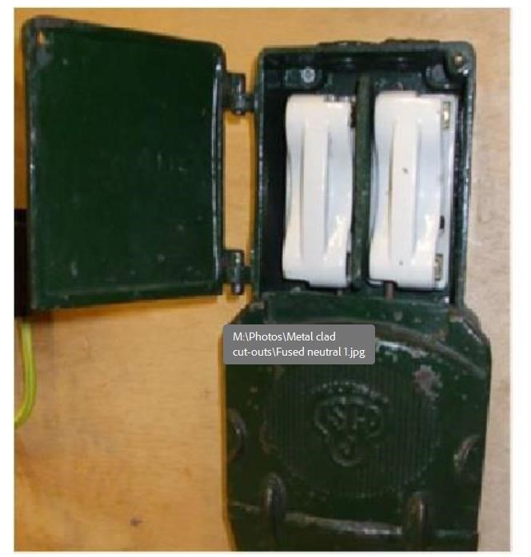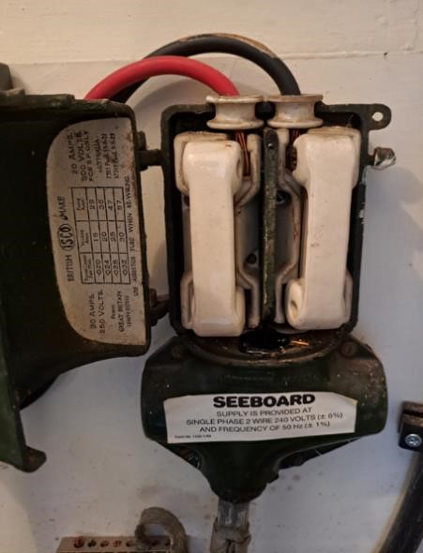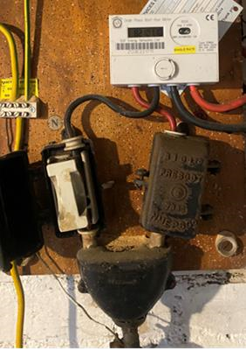

Examples appropriate to report as B11

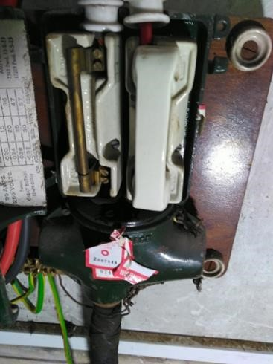
Not reportable as a B11 code. Report as appropriate C code (i.e. C11 or C18)

Example of labelling added to removable neutral carrier – to remove risk of incorrect reporting- not reportable as B11.

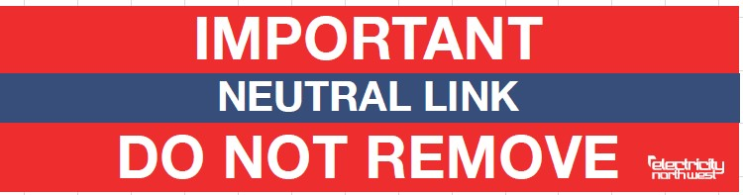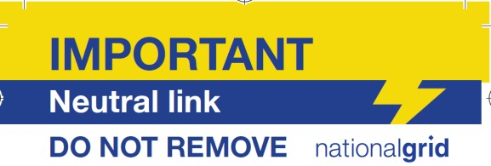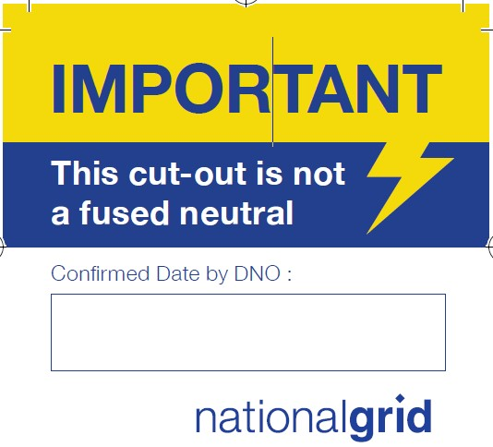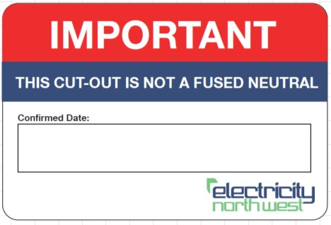

Usual Placement of Labels:

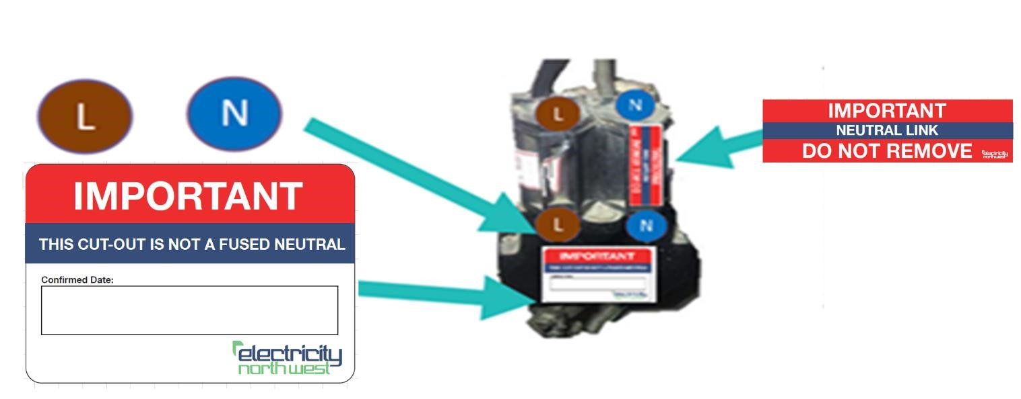

Examples of BNO Assets:

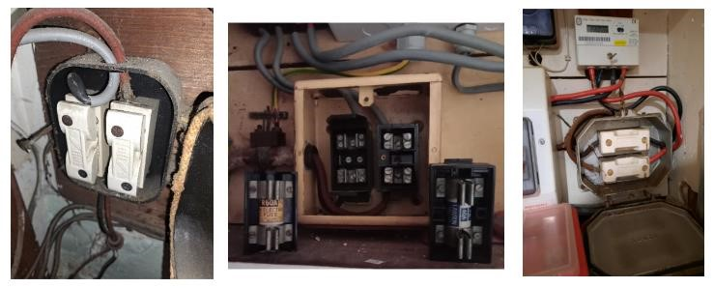
Not reportable as B11 to DNO, raise with building owner as it is a BNO asset.

Category B – Remedial Work
DNO work required for you to complete your work
Asset Condition Code: B12 | Code Description:  DNO owned CT metering equipment issue

Notes:
Current transformer (CT) operated metering equipment may be owned by parties other than the DNO (e.g. the customer) – irrespective of ownership, issues involving this equipment should be reported as Code B12.
Issues/information with regard to the incoming service cable and/or cut-out should be reported using the appropriate A, B and C Code.
This Code is not to be used to report a lack of or incomplete DNO owned CT metering equipment commissioning or documentation as required under the Balancing and Settlement Code (BSC) CoP4, or where the DNO metering equipment does not meet the accuracy requirements of the relevant BSC CoP, but is otherwise safe.
This Code should not be used to inform the DNO of installation issues prior to commissioning new CT metering equipment on site as these defects should be communicated via the business as usual processes for new connections.
Where you discover that the building / enclosure housing metering equipment is unsafe you should liaise with the customer to request that these issues are addressed.
Description:
In addition to the supply cut-out / industrial service unit (ISU), for CT operated metering systems, the DNO can provide metering equipment typically consisting of, CTs, voltage transformer (VT) (for high voltage systems), test terminal block, local isolation metering potential fuses and link, associated wiring up to and including the test terminal block, and a metering panel. The CTs may be housed in DB switchgear, a CT chamber, ISU or the meter panel.
This Code should be used where the DNO owned CT metering equipment is damaged or faulty such that it prevents metering work and/or any subsequent commissioning from being carried out.
For example:
- Damaged or insecure meter panel or CT chamber;
- Damaged CT or VT;
- Damaged wiring loom (up to the point of interface, such as the test terminal block and/or fuses/link);
- Shorting links on CT applied that cannot be accessed by the Meter Operative;
- Test terminal block missing or faulty;
- VT primary fuse blown;
- Inaccessible or non-standard types of VT secondary and LV metering potential fuse blown Although VT secondary fuses and metering potential fuses up to and including the point of interface are the responsibility of the DNO, normally it would be sensible for the Meter Operative to replace blown fuses, assuming safe access and the operative is confident it is safe to replace (i.e. cause of blown fuse established);

- CT or VT secondary circuit not connected to earth;
- Unexpected voltages or currents at the interface which the Meter Operative is unable to resolve (e.g. indicative of a fault or wiring alterations on the DNO side of the interface).

CT installation with missing test terminal CT wiring insulation damaged by rodent
block infestation exposing inner conductor
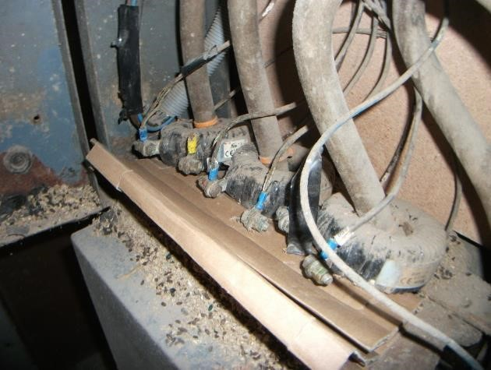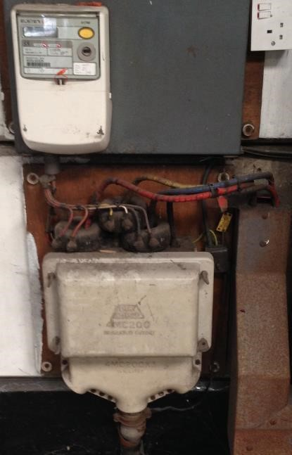

Actions:
- Wherever possible, for safety and security reasons ensure the DNO equipment is sealed before leaving site;
- Stop work and do not commence your meter installation activity;
- Report the issue to the DNO via the data flow system – report as Code B12. As this Code can be used for a variety of issues please provide a full description in the free text field;
- Provide the DNO with the customer’s name and contact number using the data flow system;
- To ensure the customer is fully aware of next steps, leave a Category B Customer Notification Card (or equivalent) to advise the customer to expect communication from the DNO requesting an appointment to visit site to inspect the DNO equipment.

Category C Issues/Information
Asset Issue/Information Codes – an issue with/information on the DNO equipment that is neither a category A issue nor a category B issue. Report these characteristics to the DNO using the data flow process. It is not generally necessary to inform the customer of an Asset Issue/Information Code reported as this may create an unreasonable expectation of DNO intervention.
Any actions/work carried out by the Meter Operative at site shall be completed in accordance with their company policies and procedures.
Category C Codes are used to inform the DNO of an asset issue/information only and MUST NOT prevent your work being carried out.
It is not generally necessary to inform the customer of an Asset Issue/Information Code reported as this may create an unreasonable expectation of DNO intervention.
Only report one Code per MPAN e.g. a C Code data flow SHOULD NOT be sent if a category A or a B issue has already been reported.
Where there are multiple DNO related issues at one MPAN, report the most serious one using the relevant Code. Report the additional issues using the free text field or if reporting a category A issue mention any additional issues to the DNO call centre agent.
Ensure that safety and other issues are properly resolved.
When reporting category C (asset issue/information) characteristics, as you can only report one Code per service position, you should report using the highest priority Code and use the free text field to report any additional issues/information.
The priority of C Code reporting is below:
- Single insulated DNO conductor (phase or non-PME neutral (C19)
- Missing combined neutral-earth cover on DNO equipment (C20)
- Rewirable cut-out fuse (C18)
- Lower rating fuse or cut-out (less than 60A) (C03)
- Asbestos component identified in DB equipment (C11)
- Metal-encased cut-out (C06)
- Signs of bitumen compound leaking (C02)
- DNO equipment mounted on asbestos board (C16)
- DNO equipment unable to be securely sealed (C07)
- Non-standard PME connection arrangement (C21)
- Black plastic cut-out (C17)
- DNO cable terminating into DB equipment is VIR/MICC (C15)
- Fed from distribution board – local/remote from meter (C14)
Note: Category A and B Code reports must always take priority over category C Code reports.

Category C – Asset Issue/Information
Continue with your work but report the issue/information to the DNO via data flow
Asset Condition Code: C02 | Code Description:  Signs of bitumen compound leaking

Description:
A situation where:
  - There is no evidence of the DNO equipment currently operating hot;
  - The DNO equipment appears in all other respects to be in good condition; and
  - Compound has obviously leaked from the cut-out previously but is not currently leaking.
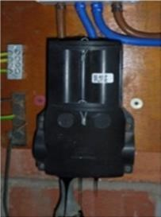
If the compound is currently leaking, report as Code A01.

As you can only report one Code per service position, the priority of the below issues/information is in the order that they should be reported. So, for example, if you have identified that there are historic signs of bitumen leaking providing there are no other higher priority issues/information, Code C02 should be reported with details of any other reportable characteristics in the free text field.
The priority of C Code reporting is below:
  - Single insulated DNO conductor (phase or non-PME neutral (C19)
  - Missing combined neutral-earth cover on DNO equipment (C20)
  - Rewirable cut-out fuse (C18)
  - Lower rating fuse or cut-out (less than 60A) (C03)
  - Asbestos component identified in DNO equipment (C11)
  - Metal-encased cut-out (C06)
  - SIGNS OF BITUMEN COMPOUND LEAKING (C02)
  - DNO equipment mounted on asbestos board (C16)
  - DNO equipment unable to be securely sealed (C07)
  - Non-standard PME connection arrangement (C21)
  - Black plastic cut-out (C17)
  - DNO cable terminating into DNO equipment is VIR/MICC (C15)
  - Fed from distribution board – local/remote from meter (C14)
Note: Category A and B Code reports must always take priority over category C Code reports.
Actions:
- Continue with your work;
- Report the issue/information to the DNO via the data flow system – report as Code C02;
- Provide the DNO with the customer’s name and contact number using the data flow system;
- It is not generally necessary to inform the customer of an Asset Issue/Information Code reported as this may create an unreasonable expectation of DNO intervention.

Category C – Asset Issue/Information
Continue with your work but report the issue/information to the DNO via data flow
Asset Condition Code: C03 | Code Description:  Lower rating fuse or cut-out (less than 60A)

Description:
Any service DBO equipment where when the fuse carrier is removed or the DNO equipment cover is opened, it is evident that the fuse has a maximum rating of less than 60 amps, look for: • Indication on the face of the cut-out that the rating is less than 60 amps; • Indication on the fuse that its rating is less than 60 amps.
As well as being used to report small fuses, this Code must also be used to report situations where the cut-out is rated at less than 60 amps. Look for an indication on the DNO equipment (moulding or name-plate) by the manufacturer that the cut-out rating is less than 60 amps.
As you can only report one Code per service position, the priority of the below issues/information is in the order that they should be reported. So, for example, if you have identified that the fuse or cut- out is rated at less than 60A providing there are no other higher priority issues/information, Code C03 should be reported with details of any other reportable characteristics in the free text field.
The priority of C Code reporting is below:
- Single insulated DNO conductor (phase or non-PME neutral (C19)
- Missing combined neutral-earth cover on DNO equipment (C20)
- Rewirable cut-out fuse (C18)
- LOWER RATING FUSE OR CUT-OUT (LESS THAN 60A) (C03)
- Asbestos component identified in DNO equipment (C11)
- Metal-encased cut-out (C06)
- Signs of bitumen compound leaking (C02)
- DNO equipment mounted on asbestos board (C16)
- DNO equipment unable to be securely sealed (C07)
- Non-standard PME connection arrangement (C21)
- Black plastic cut-out (C17)
- DNO cable terminating into DNO equipment is VIR/MICC (C15)
- Fed from distribution board – local/remote from meter (C14)
Note: Category A and B Code reports must always take priority over category C Code reports.
Actions:
- Continue with your work;
- Report the issue/information to the DNO via the data flow system – report as Code C03;
- Provide the DNO with the customer’s name and contact number using the data flow system;
- It is not generally necessary to inform the customer of an Asset Issue/Information Code reported as this may create an unreasonable expectation of DNO intervention.

Category C – Asset Issue/Information
Continue with your work but report the issue/information to the DNO via data flow
Asset Condition Code: C06 | Code Description:  Metal-encased cut-out

Description:
Any property where:
- The electricity service cut-out is manufactured from a metallic base material; and • The DNO equipment has not been identified as having a category A (emergency) or B (remedial work) issue.
For the avoidance of doubt, DO NOT report metal-encased distribution boards.
Examples of a metal-encased cut-out include:
• Pressed steel boxes;
- Cast metal boxes.
As you can only report one Code per service position, the priority of the below issues/information is in the order that they should be reported. So, for example, if you have identified that the cut-out is metal-encased providing there are no other higher priority issues/information, Code C06 should be reported with details of any other reportable characteristics in the free text field.

The priority of C Code reporting is below:
- Single insulated DNO conductor (phase or non-PME neutral (C19)
- Missing combined neutral-earth cover on DNO equipment (C20)
- Rewirable cut-out fuse (C18)
- Lower rating fuse or cut-out (less than 60A) (C03)
- Asbestos component identified in DNO equipment (C11)
- METAL-ENCASED CUT-OUT (C06)
- Signs of bitumen compound leaking (C02)
- DNO equipment mounted on asbestos board (C16)
- DNO equipment unable to be securely sealed (C07)
- Non-standard PME connection arrangement (C21)
- Black plastic cut-out (C17)
- DNO cable terminating into DNO equipment is VIR/MICC (C15)
- Fed from distribution board – local/remote from meter (C14)
Note: Category A and B Code reports must always take priority over category C Code reports.
Actions:
- Continue with your work;
- Report the issue/information to the DNO via the data flow system – report as Code C06;
- Provide the DNO with the customer’s name and contact number using the data flow system;
- It is not generally necessary to inform the customer of an Asset Issue/Information Code reported as this may create an unreasonable expectation of DNO intervention.

Category C – Asset Issue/Information
Continue with your work but report the issue/information to the DNO via data flow
Asset Condition Code: C07 | Code Description:  DNO equipment unable to be securely sealed

Description:
Where the sealing tag on the DNO equipment is broken, or the DNO equipment is otherwise unable to be effectively sealed.
Sealing
Sealing achieves four purposes:
    - To ensure basic safety – access to live conductors should require a tool;
    - To provide an indication of responsibility and/or the right to operate;
    - To aid with the prevention of tampering/illegal abstraction; and
    - To indicate the MOA and individual to last access the metering equipment or DNO equipment at the site, in the event of a dispute.
The CoMCoP describes the obligations on parties regarding sealing metering equipment such as the use of individually issued and registered sealing pliers. Cut-out fuse carriers can be fitted with
“tags”, e.g. top and bottom. Where they are, this enables wire and ferrule seals to be applied.

Examples: Photos showing where the tags are broken and it is not possible to seal the cut-out properly.

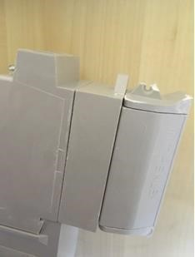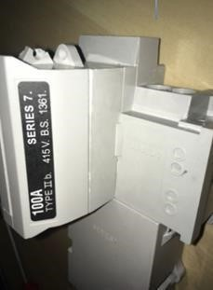

As you can only report one Code per service position, the priority of the below issues/information is in the order that they should be reported. So, for example, if you have identified that the cut-out cannot be effectively sealed providing there are no other higher priority issues/information, Code C07 should be reported with details of any other reportable characteristics in the free text field.

The priority of C Code reporting is below:
- Single insulated DNO conductor (phase or non-PME neutral (C19)
- Missing combined neutral-earth cover on DNO equipment (C20)
- Rewirable cut-out fuse (C18)
- Lower rating fuse or cut-out (less than 60A) (C03)
- Asbestos component identified in DNO equipment (C11)
- Metal-encased cut-out (C06)
- Signs of bitumen compound leaking (C02)
- DNO equipment mounted on asbestos board (C16)
- DNO EQUIPMENT UNABLE TO BE SECURELY SEALED (C07)
- Non-standard PME connection arrangement (C21)
- Black plastic cut-out (C17)
- DNO cable terminating into DNO equipment is VIR/MICC (C15)
- Fed from distribution board – local/remote from meter (C14)
Note: Category A and B Code reports must always take priority over category C Code reports.
Actions:
- Continue with your work;
- Consider alternative means of sealing, to leave the site safe. Adhesive sealing labels are an appropriate temporary alternative if one or more sealing points are damaged or if the remaining sealing points do not restrict access;
- Report the issue/information to the DNO via the data flow system – report as Code C07;
- Provide the DNO with the customer’s name and contact number using the data flow system;
- It is not generally necessary to inform the customer of an Asset Issue/Information Code reported as this may create an unreasonable expectation of DNO intervention.

Category C – Asset Issue/Information
Continue with your work but report the issue/information to the DNO via data flow
Asset Condition Code: C11 | Code Description:  Asbestos component identified in DNO equipment

Description:
On removing the cut-out or distribution board cover or fuse (usually in metal-encased cut-outs) materials used for the phase barriers or as arc suppression or protection from heat are suspected to be manufactured from asbestos containing material.
Note: If the asbestos is damaged; report as Code A12.
For more information on asbestos procedures, refer to the note on the guidance sheet for Code A12.
Examples – Asbestos component in DNO equipment

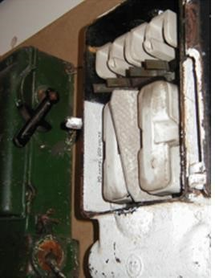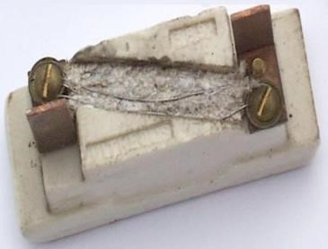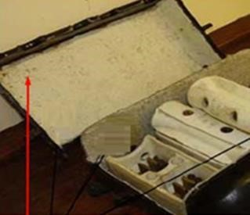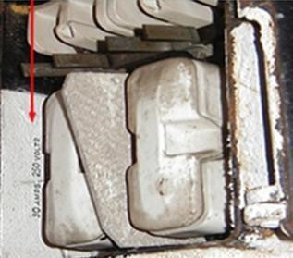

Coating

and

labels

Asbestos

wool

Asbestos

phase

barrier

As you can only report one Code per service position, the priority of the below issues/Information is in the order that they should be reported. So, for example, if you have identified that the cut-out contains asbestos components providing there are no other higher priority issues/information, Code C11 should be reported with details of any other reportable characteristics in the free text field.
The priority of C Code reporting is below:
- Single insulated DNO conductor (phase or non-PME neutral (C19)
- Missing combined neutral-earth cover on DNO equipment (C20)
- Rewirable cut-out fuse (C18)
- Lower rating fuse or cut-out (less than 60A) (C03)
- ASBESTOS COMPONENT IDENTIFIED IN DB EQUIPMENT (C11)
- Metal-encased cut-out (C06)
- Signs of bitumen compound leaking (C02)
- DNO equipment mounted on asbestos board (C16)
- DNO equipment unable to be securely sealed (C07)
- Non-standard PME connection arrangement (C21)
- Black plastic cut-out (C17)
- DNO cable terminating into DNO equipment is VIR/MICC (C15)
- Fed from distribution board – local/remote from meter (C14)
Note: Category A and B Code reports must always take priority over category C Code reports.
Actions:
- Continue with your work;
- Report the issue/information to the DNO via the data flow system – report as Code C11;
- Follow your company procedure for dealing with asbestos;
- Provide the DNO with the customer’s name and contact number using the data flow system;
- It is not generally necessary to inform the customer of an Asset Issue/Information Code reported as this may create an unreasonable expectation of DNO intervention.

An AMO document “Guidance to manage asbestos during metering activities” provides guidance to companies in developing their own asbestos safe working procedures. This will allow your company to update their asbestos procedures, which you must follow in the event of encountering asbestos- based materials.

Category C – Asset Issue/Information
Continue with your work but report the issue/information to the DNO via data flow
Asset Condition Code: C14 | Code Description:  Fed from distribution board – local/remote from meter

Description:
The service cable is fed from an internal distribution board within the building. Use this Code when the distributors’ fuse, which supplies the customer, sits in a distribution board. This includes:
- Landlord distribution boards (Building Network Operator);
- Meters relying on a distribution board fuse for protection, regardless of whether the meter has local isolation; and
- DNO owned distribution boards.

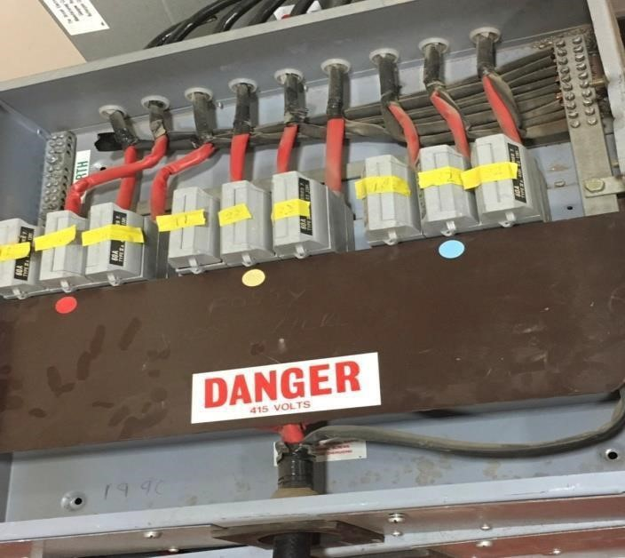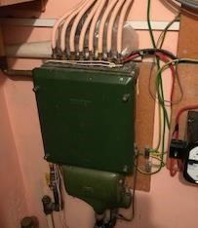
As you can only report one Code per service position, the priority of the below issues/information is in the order that they should be reported. So, for example, if you have identified that the service cable is fed from a distribution board providing there are no other higher priority issues/information, Code C14 should be reported with details of any other reportable characteristics in the free text field.
The priority of C Code reporting is below:
- Single insulated DNO conductor (phase or non-PME neutral (C19)
- Missing combined neutral-earth cover on DNO equipment (C20)
- Rewirable cut-out fuse (C18)
- Lower rating fuse or cut-out (less than 60A) (C03)
- Asbestos component identified in DNO equipment (C11)
- Metal-encased cut-out (C06)
- Signs of bitumen compound leaking (C02)
- DNO equipment mounted on asbestos board (C16)
- DNO equipment unable to be securely sealed (C07)
- Non-standard PME connection arrangement (C21)
- Black plastic cut-out (C17)
- DNO cable terminating to DNO equipment is VIR/MICC
- FED FROM DISTRIBUTION BOARD – LOCAL/REMOTE FROM METER (C14)
Note: Category A and B Code reports must always take priority over category C Code reports.
Actions:
- Continue with your work;
- Report the issue/information to the DNO via the data flow system – report as Code C14;
- Provide the DNO with the customer’s name and contact number using the data flow system;
- It is not generally necessary to inform the customer of an Asset Issue/Information Code reported as this may create an unreasonable expectation of DNO intervention.

Category C – Asset Issue/Information
Continue with your work but report the issue/information to the DNO via data flow
Asset Condition Code: C15 | Code Description:  DNO cable terminating into DNO equipment is VIR/MICC

This Code should be used for reporting service cables which are in a serviceable condition but provided via:
- Mineral Insulated Copper Clad cable (MICC, sometimes known as Pyro);
- Vulcanised India Rubber (VIR) conductors.

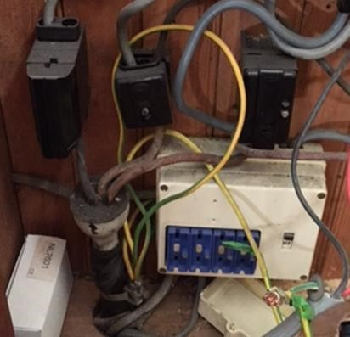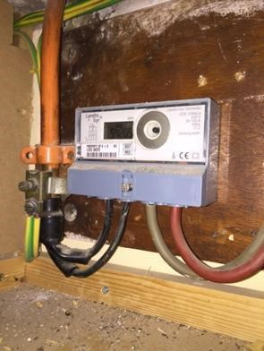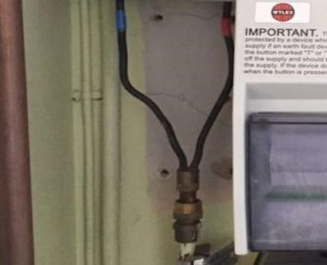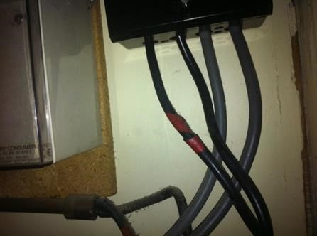
Examples

–

MICC

and

VIR

cables

Examples
of MICC
cable

Example

of
VIR

covered
conductors

Description:
The final service cable to the cut-out (sometimes referred to as ‘lead-in’) can be: • The cable between the overhead line and the cut-out; or
- Looped from another cut-out.
VIR installations are commonly:
- Found in older properties;
- Fed by an overhead service; or
- Found in multiple-occupancy buildings.
Note: THIS CODE SHOULD ONLY BE USED TO REPORT DB SERVICE CABLE INFORMATION, NOT BUILDING NETWORK OPERATOR EQUIPMENT.
Old overhead (VIR) service neutrals were sometimes terminated directly into the meter (no neutral block). Do not attempt to carry out any work, but report as Code B07.
As you can only report one Code per service position, the priority of the below issues/information is in the order that they should be reported. So, for example, if you have identified that the service cable is fed from a distribution board providing there are no other higher priority issues/information, Code C15 should be reported with details of any other reportable characteristics in the free text field.
The priority of C Code reporting is below:
- Single insulated DNO conductor (phase or non-PME neutral (C19)
- Missing combined neutral-earth cover on DNO equipment (C20)
- Rewirable cut-out fuse (C18)
- Lower rating fuse or cut-out (less than 60A) (C03)
- Asbestos component identified in DNO equipment (C11)
- Metal-encased cut-out (C06)
- Signs of bitumen compound leaking (C02)
- DNO equipment mounted on asbestos board (C16)
- DNO equipment unable to be securely sealed (C07)
- Non-standard PME connection arrangement (C21)
- Black plastic cut-out (C17)
- DNO CABLE TERMINATING INTO DB EQUIPMENT IS VIR/MICC (C15)
- Fed from distribution board – local/remote from meter (C14)
Note: Category A and B Code reports must always take priority over category C Code reports.
Actions:
- Continue with your work;
- Report the issue/information to the DNO via the data flow system – report as Code C15;
- Provide the DNO with the customer’s name and contact number using the data flow system;
- It is not generally necessary to inform the customer of an Asset Issue/Information Code reported as this may create an unreasonable expectation of DNO intervention.

Category C – Asset Issue/Information
Continue with your work but report the issue/information to the DNO via data flow
Asset Condition Code: C16 | Code Description:  DNO equipment mounted on asbestos board

Description:
Following an on-site assessment you identify that the board to which the DNO equipment is fixed is manufactured from Asbestos Containing Materials (ACM).

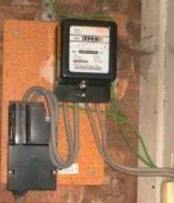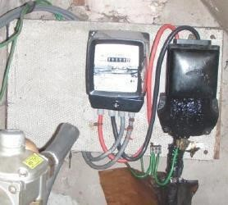
As you can only report one Code per service position, the priority of the below issues/information is in the order that they should be reported. So, for example, if you have identified that the cut-out
may be mounted on an asbestos board providing there are no other higher priority issues/information, Code C16 should be reported with details of any other reportable characteristics in the free text field.
The priority of C Code reporting is below:
  - Single insulated DNO conductor (phase or non-PME neutral (C19)
  - Missing combined neutral-earth cover on DNO equipment (C20)
  - Rewirable cut-out fuse (C18)
  - Lower rating fuse or cut-out (less than 60A) (C03)
  - Asbestos component identified in DNO equipment (C11)
  - Metal-encased cut-out (C06)
  - Signs of bitumen compound leaking (C02)
  - DNO EQUIPMENT MOUNTED ON ASBESTOS BOARD (C16)
  - DNO equipment unable to be securely sealed (C07)
  - Non-standard PME connection arrangement (C21)
  - Black plastic cut-out (C17)
  - DNO cable terminating into DB equipment is VIR/MICC (C15)
  - Fed from distribution board – local/remote from meter (C14)
Note: Category A and B Code reports must always take priority over category C Code reports.
Actions:
- If your company procedures allow, continue with your work;
- Report the issue/information to the DNO via the data flow system – report as Code C16;
- Record in the free text field if you believe the ACM board is damaged;
- Provide the DNO with the customer’s name and contact number using the data flow system;
- It is not generally necessary to inform the customer of an Asset Issue/Information Code reported as this may create an unreasonable expectation of DNO intervention.

Category C – Asset Issue/Information
Continue with your work but report the issue/information to the DNO via data flow
Asset Condition Code: C17 | Code Description:  Black plastic cut-out

Description:
Black plastic cut-outs made from phenolic materials were installed by DNOs across the UK around the period 1967 and 1992. A potential safety issue has been identified with black phenolic plastic cut- outs, whereby the plastic casing can in some circumstances become conductive leading to a risk of electric shock and / or excessive heat. This particular issue must be reported as Code A19. The purpose of this Code is to identify all cut-outs that might be of a black plastic phenolic type.
Initial Checks:
If as part of your risk assessment of the work area, you identify that the cut-out is a black plastic cut- out that may contain phenolic material then follow these actions:
- Before the operation of a cut-out - check for surface voltage on the body of the black plastic cut-out using an appropriate direct contact voltage measuring device (do not operate the DNO equipment if a voltage is detected);
- Where the test has been confirmed in accordance with the guidance in Code A19, do not operate the DNO equipment, and contact the DNO immediately by telephone reporting as Code A19;
- Only operate the DNO equipment when you are satisfied there is no sustained surface voltage present;
- Where no sustained surface voltage is recorded and it is safe to continue with your work, it is appropriate to report this Code.

Examples: Black plastic cut-outs that might be a phenolic type are shown below.

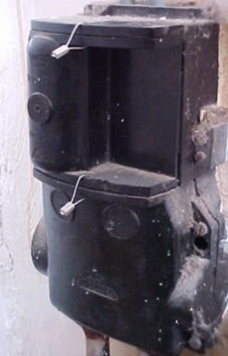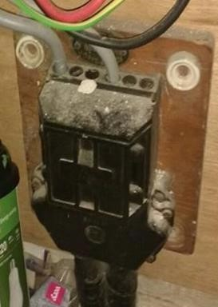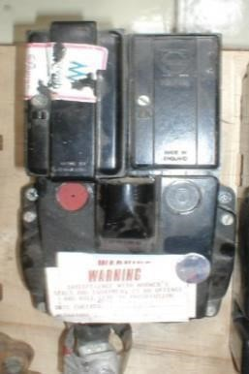

As you can only report one Code per service position, the priority of the below issues/information is in the order that they should be reported. So, for example, if you have identified that the cut-out is black plastic, providing there are no other higher priority issues/information, Code C17 should be reported with details of any other reportable characteristics in the free text field.
The priority of C Code reporting is below:
- Single insulated DNO conductor (phase or non-PME neutral (C19)
- Missing combined neutral-earth cover on DNO equipment (C20)
- Rewirable cut-out fuse (C18)
- Lower rating fuse or cut-out (less than 60A) (C03)
- Asbestos component identified in DNO equipment (C11)
- Metal-encased cut-out (C06)
- Signs of bitumen compound leaking (C02)
- DNO equipment mounted on asbestos board (C16)
- DNO equipment unable to be securely sealed (C07)
- Non-standard PME connection arrangement (C21)
- BLACK PLASTIC CUT-OUT (C17)
- DNO cable terminating into DNO equipment is VIR/MICC (C15)
- Fed from distribution board – local/remote from meter (C14)
Note: Category A and B Code reports must always take priority over category C Code reports.
Actions:
- Only operate the DNO equipment when you are satisfied there is no sustained surface voltage present;
- Continue with your work;
- Report the issue/information to the DNO via the data flow system – report as Code C17;
- Provide the DNO with the customer’s name and contact number using the data flow system;
- It is not generally necessary to inform the customer of an Asset Issue/Information Code reported as this may create an unreasonable expectation of DNO intervention.

Category C – Asset Issue/Information
Continue with your work but report the issue/information to the DNO via data flow
Asset Condition Code: C18 | Code Description:  Rewirable cut-out fuse

Description:
Any DNO service equipment where, when the fuse carrier is removed, or the DNO equipment cover is opened, it is evident that the fuse is of the rewireable type (of any rating).

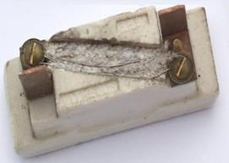

As you can only report one Code per service position, the priority of the below issues/information is in the order that they should be reported. So, for example, if you have identified that the cut-out has a rewireable fuse, providing there are no other higher priority issues/information, Code C18 should be reported with details of any other reportable characteristics in the free text field.
The priority of C Code reporting is below:
  - Single insulated DNO conductor (phase or non-PME neutral (C19)
  - Missing combined neutral-earth cover on DNO equipment (C20)
  - REWIREABLE CUT-OUT FUSE (C18)
  - Lower rating fuse or cut-out (less than 60A) (C03)
  - Asbestos component identified in DNO equipment (C11)
  - Metal-encased cut-out (C06)
  - Signs of bitumen compound leaking (C02)
  - DNO equipment mounted on asbestos board (C16)
  - DNO equipment unable to be securely sealed (C07)
  - Non-standard PME connection arrangement (C21)
  - Black plastic cut-out (C17)
  - DNO cable terminating into DNO equipment is VIR/MICC (C15)
  - Fed from distribution board – local/remote from meter (C14)
Note: Category A and B Code reports must always take priority over category C Code reports.
Actions:
- Continue with your work;
- Report the issue/information to the DNO via the data flow system – report as Code C18;
- Provide the DNO with the customer’s name and contact number using the data flow system;
- It is not generally necessary to inform the customer of an Asset Issue/Information Code reported as this may create an unreasonable expectation of DNO intervention.

Category C – Asset Issue/Information
Continue with your work but report the issue/information to the DNO via data flow
Asset Condition Code: C19 | Code Description:  Single insulated DNO conductor (phase or non-PME neutral)

Note:
For clarification of a non-PME service, refer to ‘Explanation of earthing arrangements’ in Code A07.
Description:
This Code should be used for reporting incoming service cables to the DNO equipment which are in a serviceable condition but have single insulation covering the conductor(s) and are not mechanically protected.
Examples where there is no mechanical protection include:
- Missing service cable crutch cover (on non-PME service);
- Insulated trousers which have slipped down the service cable crutch.
Do not report single insulated combined neutral-earth conductors associated with PME electricity services as these are not considered to be live conductors.
Report exposed combined neutral-earth conductors associated with PME electricity services as Code C20 if not mechanically protected.
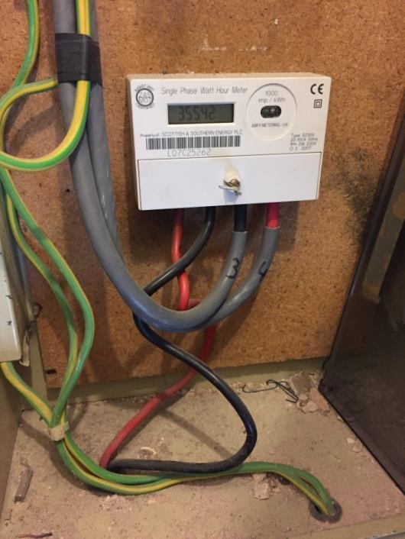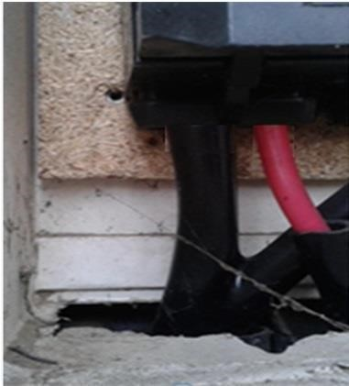
Examples

–

single

insulated

service

cables

As you can only report one Code per service position, the priority of the below issues/information is in the order that they should be reported. So, for example, if you have identified that the cut-out has a single insulated conductor, providing there is no category A or B issues present, Code C19 should be reported with details of any other reportable characteristics in the free text field.

The priority of C Code reporting is below:
- SINGLE INSULATED DB CONDUCTOR (PHASE OR NON-PME NEUTRAL) (C19)
- Missing combined neutral-earth cover on DNO equipment (C20)
- Rewirable cut-out fuse (C18)
- Lower rating fuse or cut-out (less than 60A) (C03)
- Asbestos component identified in DNO equipment (C11)
- Metal-encased cut-out (C06)
- Signs of bitumen compound leaking (C02)
- DNO equipment mounted on asbestos board (C16)
- DNO equipment unable to be securely sealed (C07)
- Non-standard PME connection arrangement (C21)
- Black plastic cut-out (C17)
- DNO cable terminating into DNO equipment is VIR/MICC (C15)
- Fed from distribution board – local/remote from meter (C14)
Note: Category A and B Code reports must always take priority over category C Code reports.
Actions:
- Continue with your work;
- Report the issue/information to the DNO via the data flow system – report as Code C19;
- Provide the DNO with the customer’s name and contact number using the data flow system;
- It is not generally necessary to inform the customer of an Asset Issue/Information Code reported as this may create an unreasonable expectation of DNO intervention.

Category C – Asset Issue/Information
Continue with your work but report the issue/information to the DNO via data flow
Asset Condition Code: C20 | Code Description:  Missing combined neutral-earth cover on DNO equipment

Description:
This Code should be used for reporting combined neutral-earth covers on DNO equipment that by design should not be missing.
This Code should only be used for combined neutral-earth (PME) systems.
Examples where Code C20 SHOULD be used are:
- Missing combined neutral-earth covers forming part of the DNO equipment;
- Missing cut-out crutch cover where no other protection is installed (e.g. insulated ‘Y piece’ shroud) and the neutral-earth conductor is un-insulated;
- Missing neutral-earth terminal access covers that cannot be remediated by the Meter Operative.

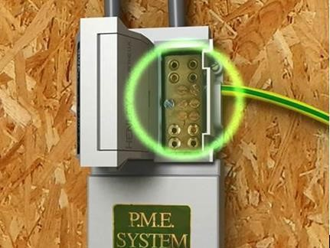

Examples where Code C20 SHOULD NOT be used are:
- All exposed neutral conductors associated with non-PME supplies (this should be reported as Code A07);
- By design un-insulated earth blocks;
• Missing insulated earth block covers.
As you can only report one Code per service position, the priority of the below issues/information is in the order that they should be reported. So, for example, if you have identified that the cut-out has missing combined neutral-earth cover, providing there are no other higher priority issues/information, Code C20 should be reported with details of any other reportable characteristics in the free text field.

The priority of C Code reporting is below:
- Single insulated DNO conductor (phase or non-PME neutral (C19)
- MISSING COMBINED NEUTRAL-EARTH COVER ON DNO EQUIPMENT (C20) iii. Rewirable cut-out fuse (C18)
- Lower rating fuse or cut-out (less than 60A) (C03)
- Asbestos component identified in DNO equipment (C11)
- Metal-encased cut-out (C06)
- Signs of bitumen compound leaking (C02)
- DNO equipment mounted on asbestos board (C16)
- DNO equipment unable to be securely sealed (C07)
- Non-standard PME connection arrangement (C21)
- Black plastic cut-out (C17)
- DNO cable terminating into DNO equipment is VIR/MICC (C15)
- Fed from distribution board – local/remote from meter (C14)
Note: Category A and B Code reports must always take priority over category C Code reports.
Actions:
- Continue with your work;
- Report the issue/information to the DNO via the data flow system – report as Code C20;
- Provide the DNO with the customer’s name and contact number using the data flow system;
- It is not generally necessary to inform the customer of an Asset Issue/Information Code reported as this may create an unreasonable expectation of DNO intervention.

Category C – Asset Issue/Information
Continue with your work but report the issue/information to the DNO via data flow
Asset Condition Code: C21 | Code Description:  Non-standard PME connection arrangement

Description:
Some service termination arrangements may be found to have non-standard connection arrangements where SNE /TNS supplies have been converted to PME. Most of these scenarios were created many years ago and it is unclear which industry party was involved/responsible at the time. Three typical scenarios of a non-standard PME connection arrangement are shown below and are all electrically sound.

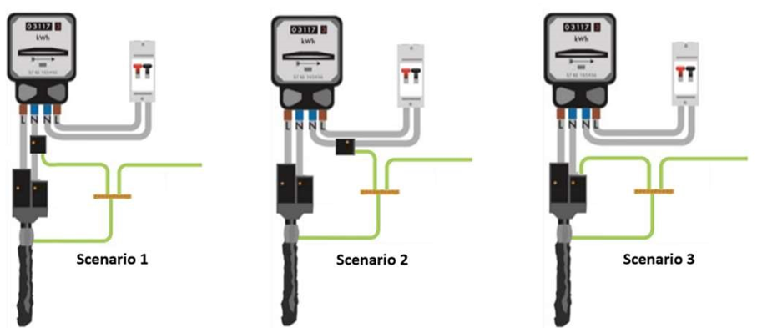

For the 3 schematic earth connection arrangements above:
- Where scenario 1 is discovered, and the neutral tail between cut-out and connector block needs to be replaced before you can complete your work, report as Code B07. If not, continue with your work and report as Code C21.
- Where scenario 2 or 3 are discovered and it doesn’t prevent metering work being completed, report as Code C21.

As you can only report one Code per service position, the priority of the below issues/information is in the order that they should be reported. So, for example, if you have identified that there is a non-standard PME connection arrangement, providing there are no other higher priority issues/information, Code C21 should be reported with details of any other reportable characteristics in the free text field.

The priority of C Code reporting is below:
- Single insulated DB conductor (phase or non-PME neutral (C19)
- Missing combined neutral-earth cover on DB equipment (C20)
- Rewireable cut-out fuse (C18)
- Lower rating fuse or cut-out (less than 60A) (C03)

- Asbestos component identified in DB equipment (C11)
- Metal-encased cut-out (C06) vii. Signs of bitumen compound leaking (C02)
- DB equipment mounted on asbestos board (C16)
- DB equipment unable to be securely sealed (C07)
- NON-STANDARD PME CONNECTION ARRANGEMENT (C21)
- Black plastic cut-out (C17)
- DB cable terminating into DB equipment is VIR/MICC (C15)
- Fed from distribution board – local/remote from meter (C14)

Note: Category A and B Code reports must always take priority over category C Code reports.

Actions:
- Continue with your work;
- Report the issue/information to the DB via the data flow system – report as Code C21;
- Provide the DB with the customer’s name and contact number using the data flow system.

The following photos show some examples of scenarios that are reportable to the DB via Code C21. A main feature of this arrangement is that there is a common/shared connection position (customers earth facility) for the cable sheath earth, neutral cable out of the neutral block and the customers’ earth.

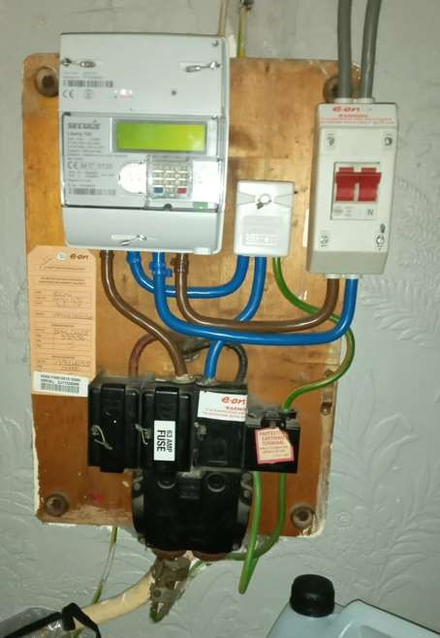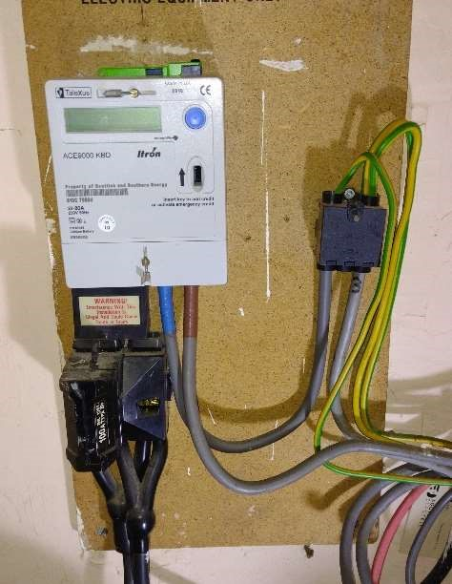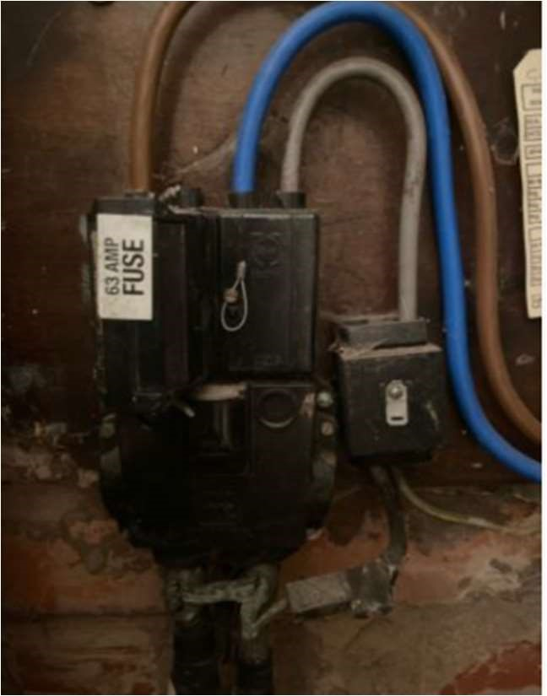

Scenario 1 Scenario 2 Scenario 3

Appendix I

Commonly Used Terms

AIB | Asbestos Insulated Board
ACM | Asbestos Containing Material
AMO | Association of Meter Operators
BNO | Building Network Operator
Code | Asset condition code
DCUSA | Distribution Connection and Use of System Agreement
DNO | Distribution Network Operator
DTC | Data Transfer Catalogue
ENA | Energy Networks Association
ESQCR | Electricity Safety, Quality and Continuity Regulations
HSE | Health and Safety Executive
IDB | Independent Distribution Network Operator
MICC | Mineral Insulated Copper Clad
MO | Meter Operator/Operative
MPAN | Meter Point Administration Number
MRA | Master Registration Agreement
PME | Protective Multiple Earthing
PPE | Personal Protective Equipment
SFIC | Safety and Faults Information Centre
SLA | Service Level Agreement as defined in DCUSA
VIR | Vulcanised India Rubber

Appendix II
Identifying the Distribution Business
The DNOs can be identified from the first two digits of the MPAN:

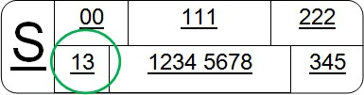

First 2 digits | Area | Distribution Network Operators (DBs)
10 | Eastern England | UK Power Networks (UKPN) – Eastern Power Networks (EPN)
11 | East Midlands | National Grid Electricity Distribution (NGED) – East Midlands
12 | London | UK Power Networks (UKPN) – London Power Networks (LPN)
13 | Cheshire, Merseyside & North Wales | SP Energy Networks (SPM) – Cheshire, Merseyside and North Wales
14 | West Midlands | National Grid Electricity Distribution (NGED) – West Midlands
15 | North Eastern England | Northern Powergrid (NPg)
16 | North Western England | Electricity North West (ENW)
17 | Northern Scotland | Scottish and Southern Electricity Networks– Scottish Hydro Electric Power
18 | Southern Scotland | SP Energy Networks (SPD)
19 | South Eastern England | UK Power Networks (UKPN) – South Eastern Power Networks (SPN)
20 | Southern England | Scottish and Southern Electricity Networks – Southern Electric Power
21 | South Wales | National Grid Electricity Distribution (NGED) – South Wales
22 | South West England | National Grid Electricity Distribution (NGED) – South West
23 | Yorkshire | Northern Powergrid (NPg)

First 2  digits | Independent Distribution Network Operators (IDBs)
24 | Independent Power Networks Ltd
25 | ESP Electricity
26 | Last Mile Electricity Ltd
27 | The Electricity Network Company Ltd
28 | UK Power Networks (iDB) Ltd
29 | Harlaxton Energy Networks Ltd
30 | Leep Electricity Networks Ltd
31 | UK Power Distribution Ltd

32 | Energy Assets Networks Ltd
33 | Eclipse Power Network Ltd
34 | Murphy Power Distribution Ltd
35 | Fulcrum Electricity Assets Ltd
36 | Vattenfall Networks Ltd
37 | Forbury Assets Ltd
 | Utility Assets Network Ltd

Current emergency and dangerous situation (Category A) reporting contact details are available on the Metering Hub of the REC Portal under DNO and MEM Operational Contact List.

Appendix III
Category A Customer Notification Card

Visit Required by the Electricity Network Operator
- During the meter installation visit, an issue has been discovered that needs to be investigated/resolved by ………………………………………………..................................., the network operator who manage the local electricity network which delivers power to your home.
- The equipment in your home is in a safe condition and your network operator has been contacted to make them aware of the situation. They will be in contact with you within the next few hours to inspect their equipment, and carry out any necessary work.
- To carry out the work your network operator will need access to your home so please ensure that an adult is available to provide access.
- Following confirmation from the network operator that their work has been completed, and the new meter has not already been installed, your electricity supplier will contact you to arrange a further visit to complete the meter installation.
If you need to contact your network operator regarding their visit, please call
………………………………………………………… quoting reference number ………………………………………………………….
Category A report

Category B Customer Notification Card

Visit Required by the Electricity Network Operator
- During the meter installation visit, an issue has been discovered that needs to be investigated/resolved by ………………………………………………..................................., the network operator, who manage the local electricity network which delivers power to your home.
- The equipment in your home is in a safe condition and your network operator will be contacted within the next five working days to make them aware of the situation. They will be in contact with you within the next three weeks to arrange a visit to inspect their equipment, and carry out any necessary work.
- To carry out the work your network operator will need access to your home so please ensure that an adult is available to provide access.
- Following confirmation from the network operator that their work has been completed, your electricity supplier will contact you to arrange a further visit to complete the meter installation.
If you need to contact the network operator regarding their visit, please call
…………………………………............. quoting the following Meter Point Administration
Number (MPAN) …………………………………………………
Category B report

Appendix IV
Categorisation of a Vulnerable Customer

Category | Group
Heart/ Lung & Ventilator | Medically Dependent Equipment
Dialysis, Feeding Pump & Auto Medication | Medically Dependent Equipment
Nebuliser and Apnoea Monitor | Medically Dependent Equipment
Oxygen Concentrator | Medically Dependent Equipment
Medicine Refrigeration | Medically Dependent Equipment
Careline/ Telecare System | Medically Dependent Equipment
MDE Electric Showering | Medically Dependent Equipment
Stair Lift/ Hoist/ Electric Bed | Medically Dependent Equipment
Chronic/ Serious Illness | Chronic/ Serious Illness
Post Hospital Recovery | Temporary
Life Changes | Temporary
Young Adult Householder | Temporary
Physical Impairment | Poor Mobility
Unable to Answer Door/ Restricted Movement | Poor Mobility
Restricted Hand Movement | Poor Mobility
Oxygen Use | Safety
Poor Sense of Smell | Safety
Dementia(s) | Industry Shared Best Practice
Mental Health | Industry Shared Best Practice
Developmental Condition | Industry Shared Best Practice
Additional Presence Preferred | Industry Shared Best Practice
Pensionable Age | Age Related
Children Under Five | Age Related
Blind | Communications
Hearing/ Speech Difficulties | Communications
Partially Sighted | Communications
Unable to Communicate in English | Communications

