This document is classified as WHITE.
Information is for public, unrestricted dissemination and publication.
REC Issues group paper

- Background – CRS Improvements Plan
Following the December 2024 Ofgem decision that the Data Communications Company (DCC) would retain its Licence and Code responsibilities for the Centralised Registration Service (CRS), a 2025/26 plan was collaboratively developed between DCC and RECCo and agreed with Ofgem. This plan focused on delivering key improvements to the REC governed CRS, to resolve issues highlighted throughout the Ofgem consultation process, in the areas of governance, data quality, service performance, and user engagement.

This plan has been presented to PAB and a commitment to share quarterly progress updates made. DCC and RECCo have shared the scope of the plan with industry, articulating the.

Core outcomes:
- Strengthen existing governance arrangements
- Improve the performance and reliability of Switching Services
- Realise the benefits identified through responses to Ofgem’s CRS consultation—both from RECCo and from across the broader retail energy industry

Focus areas:
- REL Address Data Quality: Tackle specific issues stemming from poor address data quality by developing a shared understanding of the impact and implementing an improvement process with clearly defined outcomes and mutually agreed roles and responsibilities between DCC and RECCo.
- Change Management: Refine the REC Code change management process to deliver changes more quickly and cost-effectively, while increasing engagement, communication, and certainty for users, and consider where non-code change improvements might be made.
- Engagement & Communications: Rationalise and improve interactions between DCC, RECCo, the Code Manager, and users to better meet user needs—building stronger relationships, clearer understanding, and improved service delivery.
- Incident Management: Improve the speed and transparency of incident resolution through more efficient user communications on progress and potential solutions, enrich the knowledge base, and enhance self-service tools.
- Reporting: Deliver a more efficient and cost-effective reporting framework that supports user needs and enhances transparency and understanding of Switching Service performance.

To further the aims of the Address Data Quality workstream, we would like to engage with Switching stakeholders (in particular, REC Party Suppliers, Distribution Network Operators, Gas Transporters and/or their data service Provider, to outline and verify the work to date, and to seek to understand the impacts unmatched addresses has on these parties and their end-consumers. Our primary focus is the Retail Energy Location (REL) Address, as defined within the REC – including Interpretations & Terms.

To assist us we will seek feedback from parties on the impacts and hold an in-person session.

- Survey and approach
We would like REC Party feedback on the impacts they, and their end-consumers, experience as a result of unmatched addresses, and intend to consult with REC Switching Parties, via a survey. Our proposal is to run a 6-week, survey requesting feedback from REC Parties, between the 22nd of September and the 31st of October 2025.

Within this period, we are planning to host an in-person, stakeholder engagement workshop, at DCC’s Manchester office, on Tuesday 14th of October 2025. Details will be communicated via the REC Bulletin.

Our draft survey is set out below. We are sharing it today to test it with RIG and hear your thoughts.

 | Question | Rationale
Respondents Information
1 | What is the name of your organisation? | To help us understand who is responding
2 | What is your role(s) in the Energy Market? | To help us understand who is responding
3 | What is your role(s) in your Organisation? | To help us understand who is responding
4 | Are you a REC Party or a non-Party REC Service User? | To help us understand who is responding
Using REL Address Data
4 | Does your organisation deal with the end energy consumer? | To gain an understanding about the role you play in the energy market, what consumers you provide services for, and if you use the Retail Energy Location (REL) Address.
5 | In the main does your organisation deal with Domestic or Non-Domestic Consumers?
6 | Do you use REL Address Data as part of your business processes for Switching?
7 | How do you use REL Address Data in your business processes/journeys for Switching?
Experience with REL Address Data
8 | What is the source of your Address Data? | To understand in more detail your interaction with REL Addresses and what issue you experience.
9 | Do you have any validation rules relating to the REL Address within your business journeys for Switching, if so, typically what rules are in place?
10 | How frequently do REL validation issues impact on your business processes?
11 | What types of REL validation failures occur?
12 | How do you resolve validation issues relating to the REL address?
13 | What types of address quality issues, if any, have you identified?
Impact of REL Address issues
13 | Are you aware of whether a REL address is matched or unmatched? | To understand the how poor/unmatched addresses impacts you, or your end-consumer.
14 | How frequently does unmatched REL address data impact on your business processes?
15 | How do unmatched addresses affect your operations?
16 | How do unmatched addresses affect code processes?
17 | Are issues region-specific, if so, select as apply
18 | From your perspective, what are the impacts to end consumers?
19 | On a scale of 1 (Low) to 8 (High), how significant is the impact of unmatched addresses on your Organisation?
Mitigation and Suggestions - Tackling REL Address Issues
20 | What role does your organisation currently play in REL address quality? | To understand if there are things you believe could be done to improve address quality
21 | What role do you see your organisation playing in improving REL address quality?
22 | What measures have you taken to reduce unmatched address issues?
23 | What improvements would you suggest for CRS address management?
Follow-Up
24 | Would you be willing to participate in a follow-up interview or workshop? | To understand if you’d be happy to engage with us further on your feedback.
25 | Contact Email
26 | Contact Number (optional)

- Use of the information
We intend to use survey and workshop feedback to.
- Build a current picture of the issues experienced by parties and the impacts this has on them
- Inform the focus of work to match addresses
- inform any benefits case for any identified changes (i.e., to REC processes, data system, training, guidance) or future work.

- questions for RIG
We seek to gain feedback today from RIG on:

      - Is an online survey an appropriate approach?
      - Are there any questions that are unclear and could be improved?
      - Are there any questions that we have missed?
      - Are there any questions that would be challenging for you to respond?
      - We plan for this request to be issued mid-September for completion by the end of October 2025. Is this an appropriate timeframe?
      - We plan on providing a six-week timeframe for response. Noting that this period also falls at the same time as MHHS Go-Live activity. Is this an appropriate timeframe?

Any thoughts not shared at RIG can be sent through in writing, by 17:00 Tuesday 16th September, to;
- RECCo Claire Hemmens - <claire.hemmens@retailenergycode.co.uk>
- DCC Vic Crossan - <victoria.crossan@smartdcc.co.uk>

- next steps
The feedback we receive from RIG will inform our stakeholder engagement approach on this work and may result in appropriate adjustments to the survey questions, or approach to obtaining feedback.

In the meantime, we will continue our wider work under CRS Improvements, Address Data Quality pillar, analysing the data, drawing up scenarios, and engaging with parties around any proposed trials.

Once our survey has closed, we will analyse and assess the impacts and insights shared within stakeholder responses. We will collate them thematically and articulate how this will inform our ongoing improvement work, with industry support, to mitigate the risks and impacts unmatched addresses has on parties and end-consumers. We will share our findings, conclusions, and recommended next steps with REC Performance Assurance Board, parties, and Ofgem within our quarterly updates on progress.

- Appendix
  - DCC – Switching operator Forum (SOF) February 2025, CRS Improvements PLan update.
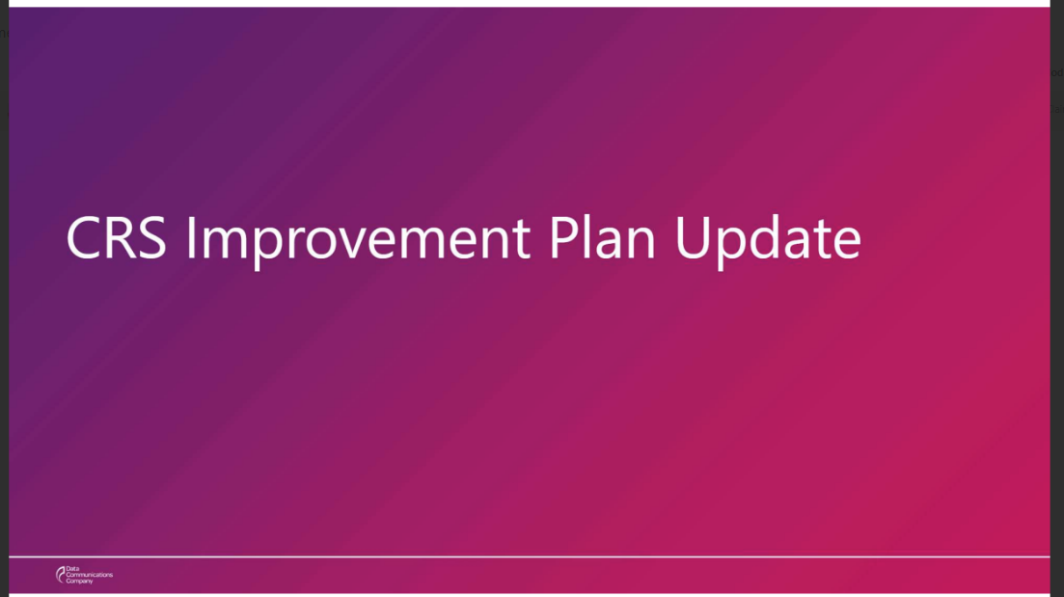

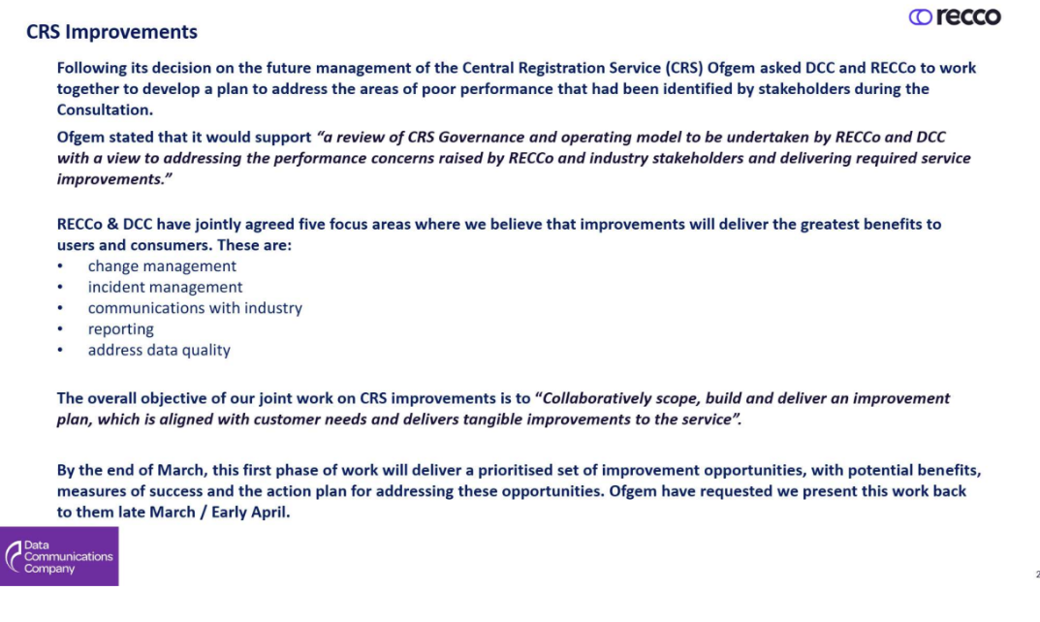

REC defines the rights and responsibilities of the CRS Provider DCC, when fulfilling its CRS roles of, Switching Operator (SO), Central Switching Service (CSS) Provider, and the CSS Certificate Authority (CSS CA).
DCC February 2025 Switching Operator Forum (SOF) update slides – included in this paper’s Appendix A.
RECCo May 2025 communication – available on our website here
Central Data Service Provider (CDSP) as defined in REC Interpretations & Terms

